Resource-Conserving Irrigation with Photovoltaic Pumping Systems
HAHN, A. * SCHMIDT, R.; TORRES, A**.; * Deutsche Gesellschaft für Technische Zusammenarbeit (GTZ) GmbH P.O. Box 5180, D-65726 Eschborn, Germany
**Universidad de Tarapacá, Centro de Energías Renovables
Casilla 6-D, Arica, Chile

ABSTRACT
In areas of developing countries with no access to grid power, diesel-driven pumps are commonly used for irrigation in farming and forestry. Diesel pumps, however, require regular maintenance and refuelling, and they place a burden on the environment. Wherever the failure of a diesel pump and the expense of its operation constitute an economic risk for the operators of small-scale irrigation systems, photovoltaic pumps (PVP) represent a reliable, alternative means of water delivery.

Keywords: PV Pumping ; Irrigation ;Developing Countries

INTRODUCTION

The use of photovoltaic pumps for irrigation represents a promising option for using solar energy productively and for generating income.
However, the use of photovoltaic pumps for small-scale irrigation is still held back by a lack of information and practical experience [1]. This kind of information is very important for convincing people in the irrigation sector that it is worth considering the option in the first place. To bridge this gap, the pilot project entitled “Resource-conserving Irrigation with Photovoltaic Pumping Systems” was started early in 1998 with a duration of four years.

PVP Irrigation Pilot Project

The Role of GTZ and its Partners:The pilot project, financed by the German Federal Ministry for Economic Cooperation and Development (BMZ), is being implemented by the Deutsche Gesellschaft für Technische Zusammenarbeit (GTZ) GmbH, in cooperation with national project executing organizations in the following countries:
Ethiopia; Bureau of Agriculture and Natural Resources Chile; Centro de Energías Renovables, University of Tarapacá Jordan; Ministry of Agriculture (in preparation)
The interdisciplinary character of the pilot project calls for close cooperation with experts from diverse professional areas. With a view to introducing sustainable dissemination processes, the suppliers of PVP irrigation systems with their local structures, together with national and private-sector institutions, are being involved in the project activities.
The project is designed to clarify whether photovoltaic pumping systems can be used to irrigate high-quality crops in a cost-effective and resource-conserving manner, and what management and technical requirements must be met in order to operate a PV-based irrigation system. In the course of the project, 10 pilot systems are being field-tested and intensively monitored at selected locations in Chile, Ethiopia and Jordan.
The field-testing of PV-based irrigation systems is intended to enable the users and operators of the pilot facilities to assess and evaluate the technology. Therefore the project places great emphasis on upgrading of project partners and training of system users.

Target Group:
Due to the comparatively high initial investment cost (see 4.), PV irrigation is not a solution for the individual subsistence farmer.
The project focuses primarily on peri-urban small and medium-size farms that use energy- and water-conserving forms of irrigation to grow cash crops on up to 3 hectares of land, hence generating income that could be used to finance a PV-based irrigation system.
Up to now, four pilot plants (0.3-1.2 kW_{p}) for cash-crop production have been installed in the Atacama Desert in the northern part of Chile. In order to investigate the application of PV-based irrigation systems in forestry, three pilot plants (0.3-0.4 kW_{p}) have been installed in Ethiopia to supply tree nurseries with irrigation water. The aforementioned systems have been in operation for about two years. Another three systems for cash-crop production will be installed in Jordan in the year 2000.

Technical Aspects

The operating principle behind any photovoltaic irrigation system is quite simple. A solar generator provides electricity for driving a submersible motor pump, which in turn pumps water into an elevated water tank (see fig. 1).
The water tank bridges periods of low insolation and supplies the pressure needed for the irrigation system. One major advantage of solar pumps is that they do not require batteries, which are expensive and need a lot of maintenance.
The maintenance of a PV-based irrigation system is restricted to regular cleaning of the solar modules. Depending on the water quality, the only moving part of the system, the submersible motor pump, has to be checked every 3 to 5 years.

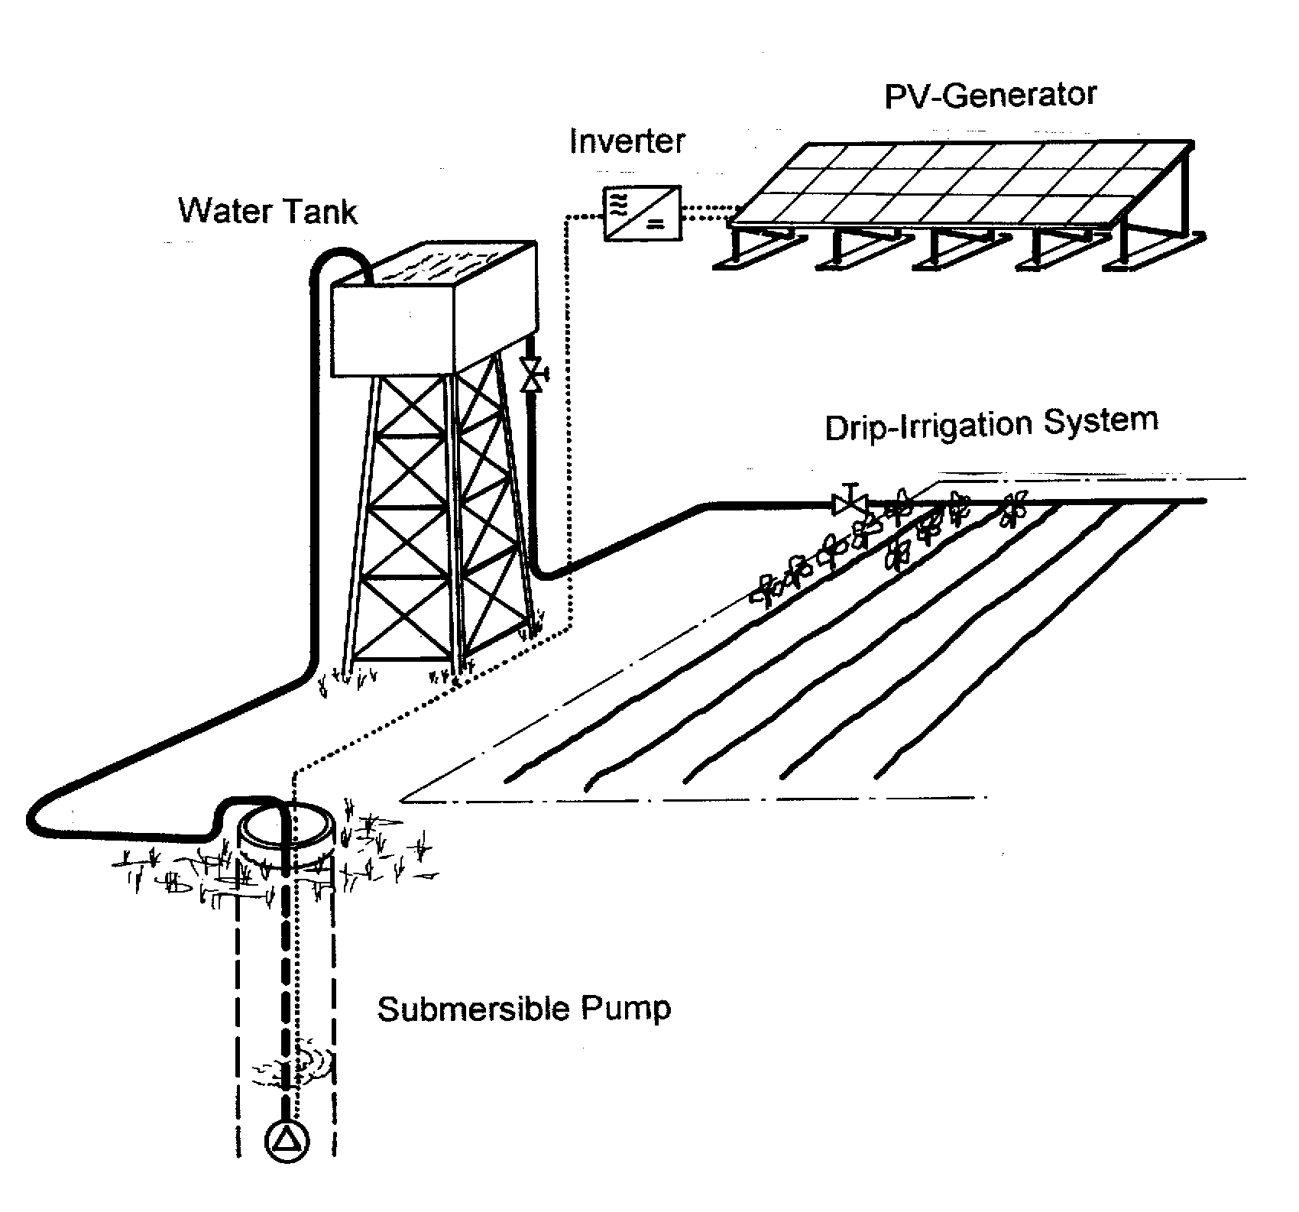

Figure 1: PVP standard system combined with a conventional drip irrigation system

Force of gravity causes the water to flow from the tank to the fields. The PV Irrigation Pilot Project is also testing units that feed directly into the irrigation system and therefore do not require a water tank.
Drip irrigation permits economical use of water, and its relatively low operating pressure makes it particularly well-suited for combination with photovoltaic pumping systems. However, it must be pointed out that such hi-tech irrigation systems are not necessary. Alternative irrigation techniques are possible, as long as they are water- and energy-conserving.

Technical Monitoring
In order to permit continuous monitoring of crucial operating parameters, all pilot sys tems are equipped with automatic data acquisition systems. In addition to the technical evaluation of the performance of the PVP irrigation systems employed, the recorded meteorological parameters (see fig. 2) facilitate management of the irrigation systems, and the water consumption data provide information on the degree of system utilization.
While the technical aspects of solar irrigation are generally regarded as adequately developed, a closer look reveals that there is still need for research at the laboratory and field-test levels. In that context, the design and testing of special low-pressure irrigation systems, including suitable filters and fertilizer injection devices, must be given special attention.
The Chilean project sites were equipped with locally available, low-pressure drip systems, suitable for operation with PVP equipment [2]. The field data confirmed that the systems are very reliable and operate at low system pressures of the order of 0.2–0.3 bar (tank height), thereby guaranteeing a uniform supply of water to the field (measured uniformity coefficient > 95 %).

Figure 2: Recorded daily global radiation (G_{d}) and evapotranspiration (ET₀) at pilot site Chaca, Atacama Desert, Chile

This presumes, of course, that all components of the drip irrigation system have been designed for such a low system pressure. The uniformity of water distribution must also be guaranteed for variable pressure conditions.
In PVP standard systems (see fig. 1) pressure fluctuations are compensated by the water tank. However, building such a tank involves much cost and effort, accounting for a correspondingly large share (35 %) of the capital outlay for a typical PVP system. On economic grounds especially, direct pumping of water to the field is advisable.

Economic Considerations

Investment Costs
Although the advantages of solar technology are evident, purchase decisions are often taken in favour of the competing diesel-powered systems. The comparatively high investment costs of the solar system are critical here. Figure 3 shows the price of a PVP system related to power generation.
Figure 3: Specific PVP system prices (ex-works) without water tank, fence and surface piping (Source: Siemens Solar)

Today the operator of a ready-to-use solar pump pays about 3 times as much as would be needed for a diesel pump with the same performance [3]. However, it is frequently overlooked that after installation the solar system incurs only a fraction of the operating costs of a diesel pump. Consequently it does not make economic sense to compare different technologies solely on the basis of the investment costs.

Specific Water Discharge Costs
The specific water discharge costs [Euro/m⁴], covering both investment and operating costs, are taken as a basis for comparing the costs of solar and diesel pumps. Furthermore, the specific water discharge costs permit an evaluation of different pumping technologies, even for sites involving different pumping heads and degrees of utilization.
The costs per cubic metre supplied are obtained by multiplying with the pumping head at the relevant location. In the drinking water sector GTZ has demonstrated the cost advantages of solar pumps in the performance range up to 2 kW_{p} in six out of seven project countries (Asia, Africa, Latin America) [3].
First results of photovoltaic water pumps applied in small-scale irrigation systems are promising, although after two years of operation the present economic data base is still insufficient for a final evaluation. However, it does suffice to identify a basic trend.
To illustrate this point, fig. 4 shows the latest results of an economic study at Vitor, one of the Chilean pilot sites.
Figure 4: Site-specific distribution of cost for potato production in Chile

It is surprising that the cost for water supply only accounts for 22 % of the total annual production costs. For potato production, the water discharge cost amounts to around 1.57 Euro-Cent/m⁴. Compared with a conventional diesel-driven pump, this particular PV-irrigation system is economically viable. However, due to the variability of country and site-specific cost factors, no generally valid conclusion can be drawn with regard to the overall viability of photovoltaic pumps.

Range of Application for PV Irrigation
Generally, it can be stated that as long as the following site-specific conditions apply, economic advantages of photovoltaic pumps over competing diesel pumps can be expected:
arid/semi-arid climate
no access to the public power grid
problems with the maintenance of diesel pumps and the supply of fuel for their operation
pumping head up to roughly 30 metres
max. field size of 3 hectares
cultivation of high-quality crops for secure markets
use of water-conserving and energy-saving methods of irrigation (e.g. drip irrigation)
high degree of system utilization through adoption of permacultures or systematic crop rotation
However, a site-specific analysis of the economic viability should always be carried out before a decision on investment is taken.

Management Requirements

Compared with a conventional pumping system, the production management of a PV-based irrigation system is somewhat more complicated, due to daily and seasonal fluctuations in the amount of energy provided by the sun.
One of the most important site-specific cost factors is the degree of system utilization, which is the ratio between the average and the maximum yearly water production. Due to fallow periods between the growing periods as well as the alternating water requirements of the crops at different growth stages, a utilization degree of ≈ 85 % is the maximum achievable [4].
Once the system is installed, one of the farmer’s main management tasks is to plan the cropping and the irrigation in order to reach a maximum degree of utilization. As a rule, this entails a change in how the farm is managed. The resultant changes in timing and work routines can be crucial for the acceptance of PVP technology.
One advantage of diesel-driven pumps is the direct availability of water after pump start-up. Some farm-workers seemed to have far more difficulties in getting used to handling a PVP-system than their employers. Accustomed to the “instant-power effect” and high pressure of diesel pumps, some farm-workers complained that the PVP system delivers too little water. In spite of initial doubts, the farmers and workers are now showing a high degree of acceptance.
The high level of reliability and low maintenance requirements of PV irrigation systems are the features most appreciated by Chilean farmers, who are used to facing daily problems with their diesel-driven pumps. That fact alone has contributed much to the acceptance of this new technology.

Environmental Impacts

Life-Cycle Analysis of PVP and Diesel Pumps
Within the scope of the pilot project, the environmental impacts of photovoltaic and diesel-driven irrigation systems were investigated. Together with the Institute for Applied Ecology, GTZ has carried out a life-cycle analysis, comparing the two different technologies [5].
The study incorporates a calculation of greenhouse-gas emissions (as CO₂ equivalents), acid-air emissions (as SO₂ equivalents) and cumulated energy requirements (CER), as well as qualitative environmental impacts, such as the pollution of water and soil by diesel oil. In addition, energy productivity factors and energy payback times of three PV technologies (monocrystalline, multicrystalline and amorphous silicon modules) have been determined.
The life-cycle comparison is performed for conditions in sun-rich developing countries (assumed solar irradiation 2000 kWh/m²*a) and analyses the so-called “cradle-to grave pathway”, including the manufacturing process, transport, operation and partial recycling of system components.
The results of the life-cycle comparison show that the greenhouse-gas emission balance of PV-pumps is approximately 10 times smaller than that of the diesel system (see fig. 5). For acid-air emissions, diesel and PV systems differ by a factor of at least 50.
Figure 5: Life-cycle comparison of greenhouse-gas emissions

Energy Productivity Factors and Payback Times
The energy productivity factors and energy payback times are considered to be further indicators for the indirect environmental burden resulting from solar modules. The energy productivity factor is defined as the quotient of the total energy supplied by an energy system during its lifetime and the total manufacturing input for this system. It thus describes the energy productivity of the system.
Figure 6: Energy productivity factors and energy payback times of PV modules

The energy payback time is calculated by dividing the energy-specific manufacturing input for an energy system by the amount of energy it supplies annually. This thus corresponds to the period in years after which an energy system has "paid back" the cost of its production through the energy it supplies.
As fig. 6 shows, both the energy productivity factors and energy payback times of PV modules are comparatively favourable in sun-rich regions.
In summary, PV modules are significantly less of an environmental burden than the diesel reference system, even for conservative assumptions regarding module life-time, rack and frame construction. In the life-cycle comparison with fossil-fuel systems, the foreseeable developments of PV manufacturing technologies will further increase their advantages. Other aspects, such as contamination of soil and ground-water resources can be completely avoided when deciding in favour of the PVP option.

CONCLUSION

In conclusion, one can state that in principle, PV irrigation systems are suitable for small-scale irrigation purposes in farming and forestry. Photovoltaic pumps require little maintenance and no fuel and therefore often constitute the only reliable solution to the problem of irrigation water supply in remote areas. The adaptation of a conventional irrigation system to the photovoltaic pump still leaves scope for component improvement.
First results concerning economic efficiency confirm that PV-pumps are able to yield cost advantages over diesel-driven pumps, as long as certain site-specific conditions apply. However, the high initial investment costs are still the main obstacle to distribution of PV pumps. Therefore it is necessary to compensate for the high investment costs by providing loans on favourable terms via development banks or through other suitable financing models.
Besides the purely financial evaluation, additional criteria are needed for an overall evaluation of PVP-technology. Fuel and lubricants for diesel pumps often pollute wells, soil and groundwater. By contrast, photovoltaic pumps are an environmentally sound and resource-conserving technology. This fact, together with the high level of technical reliability, has contributed much to the farmers' acceptance, in spite of initial doubts.

REFERENCES

Müller J., Internationaler Sach- und Wissensstand zum Thema Photovoltaische Bewässerung, GTZ, Eschborn (1999)
Torres E., Schmidt R., Ovalle R., Flores C., Torres A., Hugo Escobar A., Implementación de un programa piloto para nuevas aplicaciones de riego tecnificado utilizando bombas solares fotovoltaicas, Congreso Internacional de Energias Sustentables SENESE X, Punta Arenas, Chile (1998)
Posorski R., Haars K., The Economics of Photovoltaic Pumping Systems – Excerpt of Cross Section Study, GTZ, Eschborn (1994)
Heitkämper K., Management and Profitability of Photovoltaic Operated Pumping Systems for Irrigation in Northern Chile, University of Hohenheim, Stuttgart (2000)
Fritsche U., Life-Cycle Analysis of Photovoltaic and Diesel Pumps for Irrigation in Developing Countries, GTZ, Eschborn (2000)

