SWITCHING EMPHASES: FROM DECREASING SOIL LOSS TO INCREASING MOISTURE GAIN
T.F.Shaxson
Greensbridge, Sackville Street, Winterborne Kingston, Dorset DT11 9BJ, UK.
f.shaxson@cwcom.net

INTRODUCTION
Does the easily-spoken contraction ‘SWC‘ (as we commonly write it ) or the compressed word ‘Soilandwaterconservation’ (as we commonly say it) ‘tramline’ our thinking about how to achieve those objectives? I suggest that these over-used words, often uttered unthinkingly, obscure some unacknowledged and perhaps unreliable assumptions which impede our analyses of the problem. The emphasis is generally on soil, in both speech and action. But what about water? Regular and dependable supplies of clean water are of the highest significance to rural and urban people alike, whether they come from river, well or borehole. Relative to growing needs, water’s increasing scarcity in future could well become a greater cause of conflict - between individuals, communities and even nations - than scarcity of food.

Our discussions and papers, about ‘SWC’ and our growing interest in sustainable forms of agriculture, report our views of water in agriculture much more often in terms of quantity and quality of surface runoff than in terms of infiltration. After discussing soil moisture as a limiting factor for plant production, our interest in groundwater recharge and streamflow generally reflects a somewhat vague hope that these may be possible side benefits if enough rainwater happens to get into the soil. We assume that hydrologists will discuss such matters in other forums, but do we read and integrate their reports into our own thinking?

Even today, considering rainfed agriculture in the tropics and subtropics, and as concerns rise about ‘desertification’, soil moisture gets less attention than soil loss, even though damaging water stress in crops can develop much more quickly in plants, with concomitant effects on crop yields, than do nutrient stresses due to recurrent events and cumulative effects of erosional loss of soil particles.

Rainwater is the engine of most erosion processes in most places where they occur, yet we pay too little attention first to help the soil absorb it as rainfall in the vertical dimension, and too much to controlling, too late, its subsequent flow as runoff in the lateral dimension . Many soils have lost their native absorptive capacity due our disturbances by burning, tillage and trampling. Many years ago, the cartoon character Pogo said: “We have met the enemy and he is us.”

QUESTIONING SOME COMMON ASSUMPTIONS

The following questions are offered to provoke a greater emphasis on water in the soil than we have given it to date.

a. Where land is in process of becoming degraded, is erosion per se the prime cause of loss of soil and thus of loss of soil productivity? Or is it a consequence of water’s effects, following the alterations we have made in the ecology of the land’s interacting components?

b. Can conservation of soil particles per se reverse decline in soil productivity by raising it? Or does that do no more than stabilise the soil profile, in which water, air , organic matter, nutrient ions and plant roots then work better their astonishing processes?

c. Can differences between yields before and after soil erosion be truly attributed to the quantities of soil and water lost? Or are they more closely attributable to the differences between the qualities of the soil before erosion and of that which remains in place (though eroded) after the event, on which the next season’s crop is planted; and in particular what proportion of the difference is due to greater severity of water stress in plants now growing on the damaged soil?

d. Is cover over the soil primarily beneficial in directly reducing or halting soil erosion? Or is its capacity to minimise raindrop-impact - and thus maintain and enable increase of the infiltration-rate of rainwater, its primary (pre-erosion) benefit?

e. Are cross-slope banks and barriers to trap soil and water at intervals downslope the best ways to cope with runoff and soil loss? Or is the improvement of infiltration - towards high levels earlier provided by ‘forest-floor’ or ‘grassland-floor’ conditions - a better way to avoid erosion and simultaneously replenish soil moisture and groundwater?

f. Have our thoughts and actions become conditioned and constrained by almost a century’s widespread, detailed and sometimes unjustified emphasis more on loss of soil from the surface than gain of moisture through the surface? Is it possible that an altered emphasis towards rainwater could yield new insights and hidden information, and suggest new paths for research, extension and practical action?

HIDDEN INFORMATION
It is strange that, even though we may perhaps acknowledge or even specifically investigate the importance of infiltration, we most commonly report observations and research results in terms of runoff, and make the unspoken assumption that readers will infer what that means for infiltration. What is hidden in such reports may be information that would allow clearer quantitative linkages to be established between crop yields and soil moisture conditions than can honestly be made between them and soil losses.

A multitude of experiments and observations have been undertaken over the years to record how different treatments – e.g. degrees of cover, types of tillage, various crop rotations etc., - affect the losses of soil and water from given sites. The generally-implied assumption is that loss of yield and loss of soil are somehow intimately related.

But our interpretation changes if we allow that crop yields are limited also by rapidly-developing water stress in the plants, brought on swiftly in hot dry areas - in a matter of days - by insufficiency of moisture in the soil held at plant-available tensions. Then, in many situations, runoff can be seen as lost potential for soil moisture and possibly streamflow and deep groundwater, rather than as inconvenient and muddy torrents.

Here are some example of alternative interpretations of some published information, arising from switching emphasis from soil to water:

a. Tillage, cover and erosion in S. Australia:
Experiments were undertaken at Gympie in Queensland, Australia to investigate effects of mulch on runoff and soil loss from pineapple plantings. Over the period 5.11.92 – 14.2.95 treatments on 100-sq.m. plots compared runoff and erosion from bare plots and from mulched vs. conventionally-managed plots planted with pineapples. Results reported from 26 erosive rainfall events totalling 881.3mm (intensities ranging from 37 to 179mm/hr) were as follows:

Runoff losses from 3 treatments of pineapple plots: Gympie, Australia
Treatment  Result (from rain 881.3mm) | Bare | Conventionally managed  (unmulched) | Mulched  (finely-chopped, 8t/ha)
Total runoff 5.11.92 - 14.2.95. (as reported)  mm  (%) | 413.9  (46.96) | 257.7  (29.24) | 197.0  (22.35)
Total infiltration  (as derived)  mm  (%) | 467.4  (53.03) | 623.6  (70.75) | 684.3  (77.65)

Which would be the most useful figure for the grower: the mms. runoff (as recorded), or the mms. infiltrated (as derived)? If the latter, the question then to be asked , having regard to the water requirements of the pineapple crop for transpiration without development of damaging stress, is: Which amount of infiltration – 467.4mm, 623.6mm or 684.3mm – will be the minimum sufficient for growing an economic crop, and what is the best of these treatments to achieve it?

b. Interpreting an historical record from Tanzania
A photograph and the accompanying report from the Dodoma region of Tanzania show that long-continued land misuse over the last one hundred years has changed an area from rain-absorbing dry forest to a severely-overgrazed semi-desert. After decades of misuse, now up to 50 % of the annual rainfall of between 500 and 800 mm. is estimated to be lost as runoff , together with long-continued and widespread erosion losses of up to 135 tons soil/ha/year. But if we shift the emphasis from soil loss to the need for water gain, we can state this in the inverse way as: ‘Only between 250 and 400mm. infiltrate into the soil, and the ‘soil’ left behind is desurfaced and unfruitful subsoil’. In an area where potential evaporation is 2000mm. per year, such waste of potential soil moisture has been and continues to be catastrophic. “With the dwindling of the woodlands [due to cutting and subsequent tillage] water dwindled also. Total rainfall did not decrease, but because of land degradation rainfall became less effective than previously”. Evidently less and less rainwater, in excess of plant needs on some occasions during the rains, has been penetrating to groundwater and streamflow. The inhabitants of the area, as well as the vegetation, have been under increasingly severe water stress. By comparison with the incident rainfall, unexpected plant species more characteristic of drier areas have become more common, better adapted to the conditions of induced drought.

c. Conservation measures and streamflow, West Java.
Results on streamflow of imposing conservation measures on to 31% of a 10.2 ha. catchment in West Java are reported in one way, but re-interpretation of the diagram which illustrates the effects again reveals hidden information. Rainfall and runoff are shown together with stream discharge, on a monthly basis for three years. While the % runoff is shown, the inverse – the % of rainfall which has infiltrated and has evidently fed the streamflow – was not highlighted, though it can be roughly calculated from the diagram by subtracting runoff from rainfall. (Figure 1).
Figure 1, 1a Total monthly rainfall, runoff, infiltration and average and minimum (base flow) discharge October 1992 – September 1995
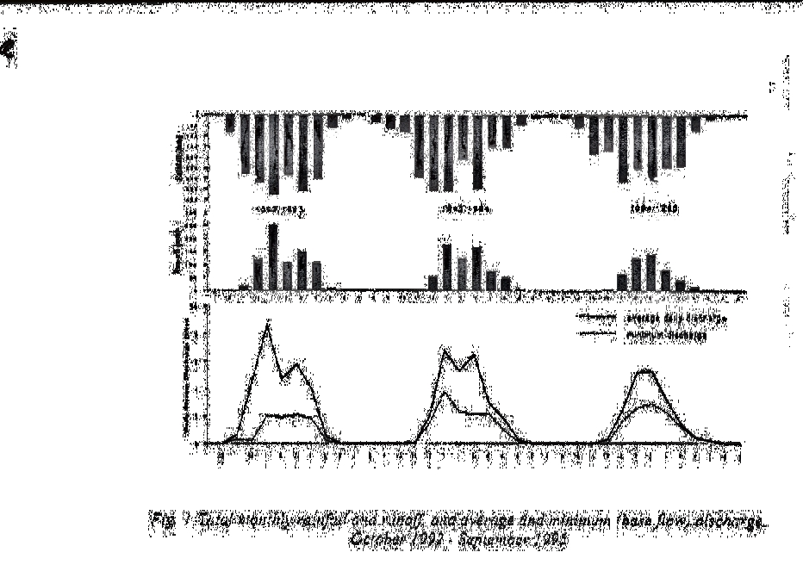

Being able to see the infiltration as well as the runoff, we can see more clearly the lag between rainfall and runoff at the beginning of each season, with a quicker reaction-time at the end of the first two seasons.

Although the intention of the trial was to investigate rainfall/streamflow relations, the measures imposed were still called ‘SWCP’ ‘ Soil and Water Conservation Practices’. Perhaps the emphasis (in this and most other situations) should change to ‘Water and soil conservation practices’, as we know that in many situations ‘if you look after the water, the soil will look after itself’.

d. Earthworms, cover and runoff, Hyderabad, India.
Investigations were undertaken to minimise runoff and increase infiltration in crusting and hardsetting Alfisols. Under simulated rainfall, the effects of mulch cover and of earthworms, separately or combined , were compared with runoff from bare plots. The results were presented as rates of runoff at five-minute intervals over 35 minutes. In order to enhance the information embedded in the quoted results, a simple mathematical transformation of the data of the graph in Diagram (a) enabled that information to be shown as cumulative depth (mms) of water infiltrated at five-minute intervals under each of the four treatments , as in Diagram (b). The information on infiltration’s contribution to soil moisture was there, which, from a root’s point of view, would have been useful also. Figure 2, 2a.

EFFECTIVE RAINFALL, SOIL AND CROP GROWTH

Rainfall precedes, and its effects are different from those of, runoff, and need to be considered separately, but in sequence, before being combined in water-and-soil-conservation (‘WSC’) proposals and programmes.

Figure 2, 2a :2: Runoff rate from four earthworm/cover treatments subjected to rainfall simulation 2a: Cumulative infiltration from four earthworm/cover treatments subjected to simulated rainfall of intensity 55mm/hr. for s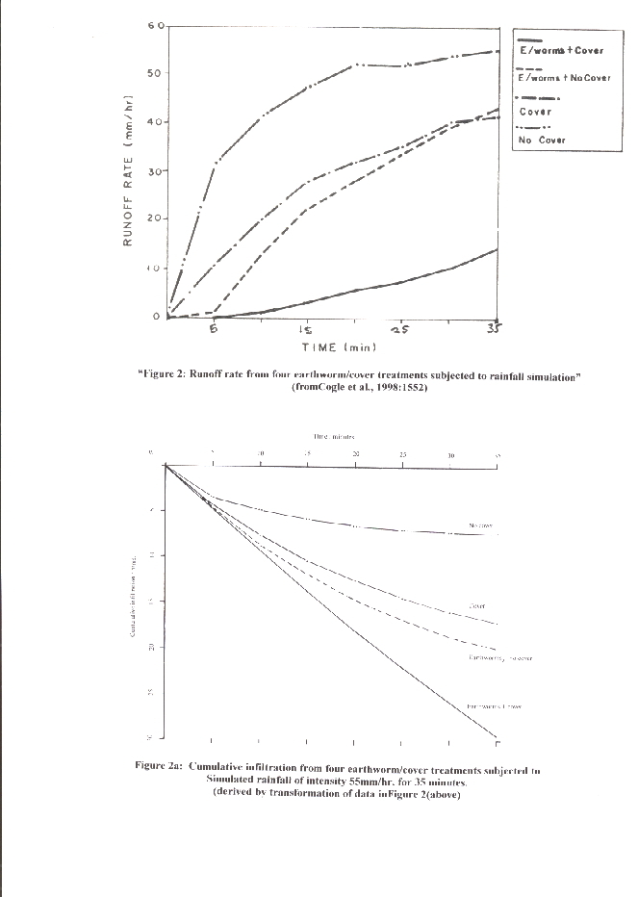

It is often implied in technical papers, though with scant justification, that all rainfall is 100% ‘effective’ for plant use and groundwater recharge. In many situations, runoff due to degradation of soil porosity represents ‘ineffectiveness’ of a proportion of the rainfall and an undesirable loss of potential soil moisture and possibly groundwater. Conversely, restoring adequate soil porosity where it has become degraded can increase the proportion of rainfall which becomes ‘effective’.

Without adequate soil moisture but adequate nutrition, root-functions of active growth and of absorption of nutrients are seriously impeded, whereas without adequate nutrients but with sufficient soil moisture plants continue to function, albeit poorly.

Farmers’ concerns relate more to their perceptions of falling productivity of their lands than to perceptions (their own or others’) of soil erosion. They may be excused from perceiving any clear link between them if neither researchers nor advisory workers can show clear quantified relations between erosion losses and yield declines. On the other hand, yield:soil-moisture relationships can be more clearly defined and demonstrated, with evidence from experiments and observations in both irrigated and unirrigated areas. Farmers are usually motivated more by considerations of water than by considerations of soil particles.

It is easy to assume that, for soils which could accept more rainwater than they currently do, additional water-entry per se will always result in yield benefit. This may be the case where lack of plant-available water in the root zone is the primary limiting factor. There are many examples where it is so – as for instance with the ‘tassa’ or ‘zai’ of West Africa, and with irrigation water applications.

If it is not the primary limiting factor, there may be no consistent beneficial effect until other limiting factors, usually inadequate nutrition, have been rectified. This is shown in a recent review of research on soil and water management in the semi-arid areas of southern and eastern Africa. This revealed a number of equivocal results after many years of work,, indicating that achieving more soil moisture in the profile did not automatically and on its own solve the yield problem. Other authors point to the need to promote those conservation-effective practices which do produce higher yields. These will include optimising differing combinations of the management of crops, soils, nutrients and rainwater – also called ‘better land husbandry’.

Nevertheless, this does not invalidate the importance of enabling rainfall to enter the soil, because even if it is not at a particular moment the chief limiting factor for growth, its movement further down to groundwater and streamflow is of increasing significance to people whose main daily concerns are for clean water, and for trees for fuelwood with which to prepare what food they have.

More attention to optimising soil moisture conditions in most seasonally-dry areas of the tropics (a) appears likely to provide more-comprehensible reasons for yield differences between treatments in both research plots and farmers’-field conditions; (b) in many cases will contribute quickly and significantly to improved yields, thereby enabling a better mutual understanding and collaboration between non-farm agriculturists and farmers; and (c) can contribute excess to groundwater rather than to surface runoff.

However, particular care is needed in deciding how, or whether, to do this if there is a danger of provoking a rise in the level of water-table of a salty groundwater, a situation which would cause dryland salinisation with disastrous consequences for plant growth – as has happened in significant areas of Australia.

CLIMATE, VEGETATION AND STREAMFLOW

The interactions between climate, vegetation and streamflow were investigated in East Africa between 1956 and 1973 , and were reported at length in 1979 . Water balance studies were undertaken to assess the hydrological effects of the following changes in land use:

* From indigenous bamboo forest to plantations of exotic conifers or grassland (Kimakia, Kenya);
* From indigenous montane forest to plantation tea (Kericho, Kenya);
* From indigenous montane forest to smallholder cultivation (Mbeya, Tanzania);
* From degraded bush to rehabilitated rangeland with bush clearing and stock control (Atumatak, Uganda).

The results reinforced understanding that water use by plants is actively controlled by meteorological conditions and vegetation type, whereas streamflow can be regarded as the ‘residual’ term in the equations where rainfall exceeds evapotanspiration. (endnote 12:275,277)

In the cases of the first three catchments, all in high-rainfall areas, the key processes were shown to be interception, infiltration rates and the control on transpiration exercised by soil moisture deficits. In the harsh dry environment of the fourth case, rainfall is insufficient in quantity and concentration to sustain permanent streamflow. This experiment’s results suggested that the changes in land-use by bush-clearing and controlled grazing would not change the situation, though the increase in infiltration would result in sporadic groundwater recharge and would extend the time during which moisture would be available for grass growth (endnote 12:214)

With respect to augmenting streamflow, a first consideration in many areas of the tropics where potential evaporation exceeds rainfall, should be to ensure as much rainwater as possible gets into the soil to become potentially effective. The second consideration should then be to adjust the vegetation component on the catchment of any stream so as to balance the need for productive use of soil moisture, via transpiration through deep- and shallow-rooted species (crops, trees), with that for groundwater replenishment that will feed streamflow. This is exemplified by the results from the Mbeya catchments (endnote 12,p.276) and elsewhere.

“At Mbeya, the streamflow from the forested catchment was markedly less than that from the cultivated catchment. Seasonal distribution was influenced particularly by the differences in dry season transpiration and, to a lesser extent, by the surprisingly small increase in surface runoff. The latter accentuated the storm peaks but the absence of transpiring vegetation for most of the dry season on the cultivated catchment resulted in lower deficits, substantially greater groundwater recharge, and dry season flow twice as great as that from the forested catchment”.

The adoption of zero-tillage - with its maintenance of crop residues - on a wide scale in Brazil has occurred because farmers found it beneficial in economic terms. But environmental benefits have also been significant: experiments showed improvement in water infiltration, from 20mm/hr to 45mm/hr through leaving mulch on the soil surface and its effects on soil properties, higher density of plant root systems and an increase in biological activity which resulted in more soil pores, much of it related to direct and indirect effects of the increased organic matter.
CONCLUSIONS
Why go so strongly chasing after soil and runoff when rainfall itself produces those problems, yet offers other potentials?

When and where the regularity and cleanness of streamflow is becoming a serious concern, we should begin to think also from the groundwater up the soil moisture column, not just from surface runoff downwards. Even if we delay making this link now, when the streamflow situation gets more desperate later it will still be the improvement of soil porosity at all levels in the profile beneath crops, trees and pastures, which will remain the key to improving streamflow. Our aim should be to get as much rainwater as necessary into the soil so as to ensure enough gets past the satisfaction of transpirational and soil-moisture-retention demands and still be able to replenish the groundwater – though not to ‘overload’ it to the point where trees and streamflow cannot deal with the excess, such that the water-table rises to excessively-shallow depth.

Land use planning begins to look as if it should be as much concerned where deep-rooted and shallow-rooted species should best be allocated positions on the (absorptive) landscape, in the interests of soil-water management, as it should be in trying to minimise erosion losses by ‘rational’ planning based on area assessments of land’s physical characteristics.

With respect to crop production and water supply, concern then automatically switches towards how best to get rainwater to enter the soil, with emphases on improvements in cover and porosity, and away from a somewhat over-done preoccupation with erosion. The very factors which enable good infiltration and maximum potential effectiveness of rainfall are the very same which avoid, or at least minimise, runoff and erosion – achieving conservation by stealth .

While it is more difficult to explore what is going on below the surface in any soil profile than it is to work with phenomena on and above the surface, we need to pay much more attention to soil as the first-line reservoir in ‘water conservation’, with dams and other surface structure for water retention in a subsidiary and complementary rank.

We should be worried by erosion and runoff as symptom of troubles with the soil itself and a failure of infiltration, in advance of our common concerns with losses of soil particles, organic matter and nutrients as commonly studied.

This lateral shift in thinking has agronomic, social and economic implications for policies, strategies and plans relating to recovering, improving and sustaining land’s potentials to produce plants and deliver water. It also (a) encourages a re-appraisal of the real effects and relative worth of some commonly-recommended but uncritically-applied ‘SWC’ measures, both structural and vegetative; (b) suggests we pay more critical attention to soil water as the key component of many processes and outcomes in the dynamics of the soil / plant / climate continuum; and (c) emphasises the importance of maximising the conservation-effectiveness of anyone’s land-use decisions and actions.

I would like to thank David Sanders and Richard Barber for their helpful comments on the draft.

REFERENCES ? REIJ C., EGER H., STEINER K., 1998: ‘From Sustainable Soil and Water Conservation to Sustainable Land Management : Some Challenges for the Next Decade’. In: Towards Sustainable Land Use – Furthering Cooperation between People and Institutions. Proc. IX ISCO Conference, Bonn. Blume, Eger, Fleischhauer, Hebel, Reij, Steiner (eds.) Advances in Geoecology 31.(vol.II). Reiskirchen (Germany): Catena Verlag GMBH. ISBN 3-923381-42-5. pp.819-826 [SM87]
GREENLAND D..J., BOWEN G., ESWARAN.,H., RHOADES R., VALENTIN C. (undated-1995?): ‘Soil, Water and Nutrient Management Research’. IBSRAM Position Paper. Bangkok: International Board for Soil Research and Management. Foreword by N.C.Brady. [SM40]
GRIESBACH J-C.,SANDERS D.: 1998: ‘ Soil and Water Conservation Strategies at Regional, Sub-regional and National Levels’. In: Towards Sustainable Land Use – Furthering Cooperation between People and Institutions. Proc. IX ISCO Conference, Bonn. Blume, Eger, Fleischhauer, Hebel, Reij, Steiner (eds.) Advances in Geoecology 31.(vol.II). Reiskirchen (Germany): Catena Verlag GMBH. ISBN 3-923381-42-5. p871. [SM87].
CIESIOLKA C.A.A, HASHIM G.M.: 2000. ‘Watershed Management for Erosion Control in Steeplands of Tropical Asia and Australia’. In: Integrated Watershed Management in the Global Ecosystem (R Lal, ed.) Boca Raton (USA): CRC Press, with SWCS. ISBN 0-8493-0702-3. pp.89,90. [SM32.11]
CHRISTIANSSON C. 1988: ‘Degradation and Rehabilitation of Agropastoral Land – Perspectives on Environmental Change in Semiarid Tanzania’. Ambio, vol.17, no. 2, 144-152. [SM84]
SINUKABAN N., PAWITAN H., ARSYAD S., ARMSTRONG J. 1998. ‘Impact of Soil and Water Conservation Practices on Stream Flows in Citere Catchment, West Java, Indonesia’. Towards Sustainable Land Use – Furthering Cooperation between People and Institutions. Proc. IX ISCO Conference, Bonn. Blume, Eger, Fleischhauer, Hebel, Reij, Steiner (eds.) Advances in Geoecology 31.(vol.II). Reiskirchen (Germany): Catena Verlag GMBH. ISBN 3-923381-42-5. p1277. [SM87].
COGLE A.L., RAO K.P.C., REDDY M.V., SRINIVASAN S.T, MEGARRY D., SMITH G.D, YULE D.F. 1998: ‘The Impact of Soil Biota and Cover on Runoff and Infiltration in a Hard Setting Alfisol in the SAT’. in: Soil and Water Conservation: Challenges and Opportunities. Proc.8th ISCO Conf., Delhi. (Bhushan, Abrol, Mohan Rao eds.) Dehra Dun: Indian Assoc. of Soil & Water Conservationists. 2 vols. ISBN 81-204-1082-x. vol. 2, p.1552. [SM91.6].
OUEDRAOGO M., KABORE v. 1996: ‘The Zai: A Traditional Technique for the Rehabilitation of Degraded Land in the Yatenga, Burkina Faso’. In: Sustaining the Soil : Indigenous Soil and Water Conservation in Africa. (Reij, Scoones, Toulmin, eds.) London: Earthscan Pubns., ISBN 1-85383 372X. pp.80-84 + photos.
MORSE K,1996. ‘A Review of Soil and Water Management Research in Semi-Arid Areas of Southern and Eastern Africa’. Greenwich (UK): Natural Resources Institute. ISBN 0 85954 462-1. 187pp.
REIJ et al., 1998 (op.cit.) p.821.[SM87].
EAST AFRICAN AGRICULTURAL AND FORESTRY JOURNAL, 1962. vol. XXVII- Special Issue. ‘Hydrological Effects of Changes in Land Use in Some East African Catchment Areas’. 131pp. [SM68].
BLACKIE J.R., EDWARDS K.A., CLARKE R.T. 1979. ‘Hydrological Research in East Africa’. E.Afr. agric.for. J. vol. 43. 1979 Special Issue. 313pp. [SM69]
PEREIRA H.C., 1973: ‘Land Use and Water Resources’. Cambridge UP. ISBN 0 521 09750 9. p.87.[SM129]
CALEGARI A., DAROLT M.R., FERRO M., 1998. ‘Towards Sustainable Agriculture with a No-Tillage System’. In: . In: Towards Sustainable Land Use – Furthering Cooperation between People and Institutions. Proc. IX ISCO Conference, Bonn. Blume, Eger, Fleischhauer, Hebel, Reij, Steiner (eds.) Advances in Geoecology 31.(vol.II). Reiskirchen (Germany): Catena Verlag GMBH. ISBN 3-923381-42-5. p.1207. [SM87]
SHAXSON T.F., 1988: ‘Conserving Soil by Stealth’. In: Conservation Farming on Steep Lands. (Moldenhauer and Hudson, eds.) Ankeny (USA): Soil & Water Cons. Soc. and World Assoc. of Soil & Water Cons. ISBN 0-935734-19-8 pp.9-17. .oOo. (Isco:SWITCHEMPHd:2/10/00)

