SOIL LOOSENING IN THE SEED ZONE AS AFFECTED BY DIFFERENT NO-TILL FURROW OPENERS UNDER DIFFERENT SOIL CONDITIONS AND CROP RESIDUE COVER RATES

TOLAª, E. H. M.; J. MÜLLER^{b}; and K. KÖLLER^{b}

ª Dept. of Agric. Eng., Faculty of Eng. & Arch., University of Khartoum PO Box 321, Khartoum - SUDAN. E-Mail: tola@ats.uni-hohenheim.de
^{b} Inst. of Agric. Eng., University of Hohenheim. Garbenstr. 9, D-70599 Stuttgart, GERMANY.
E-Mail: koeller@ats.uni-hohenheim.de

ABSTRACT

An important key in optimizing conservation tillage systems is the better understanding of the performance of different seeding openers. Soil bin experiments were conducted to investigate the effect of two no-till furrow openers on the degree of soil loosening in the seed zone which has been reported as one of the most important factors affecting soil and water conservation practices: John Deere 750-A (JD) which is selected to represent the wide range of single disc openers and Amazone no-till opener (AM) to represent hoe openers. Both openers were adjusted to operate at 50 mm soil depth and 8 km/h forward speed. These experiments were done under two soil conditions with the following physical properties in the upper 50 mm soil layer: (1) average cone index 0.60 MPa at a soil water content of 8.1 % (2) average cone index 0.85 MPa at a soil water content of 13.7 %. Experiments were conducted under three crop residue cover rates: (a) 0 t/ha (b) 3 t/ha, and (c) 8 t/ha. The soil penetration resistance is measured using a multiple cone penetrometer. The degree to which the soil in the seed zone is loosened was characterized by the ratio of the soil penetration resistance after treatments to the value before. The degree of soil loosening in the seed zone is evaluated in three different soil layers (0-50, 50-100, 100-140 mm soil depth). The most important findings of this study are: (1) the differences in the values of the degree of soil loosening in the seed zone between the two openers (single disc and hoe) is statistically significant at 0.01 level under both soil conditions and residue cover rates and the three soil layers in which Amazone hoe opener showed the higher loosening effect. (2) for the single disc opener (John Deere), soil loosening is reduced with the increase in crop residue cover rate. (3) The degree to which the soil in the seed zone is loosened by the no-till hoe opener (Amazone) is not significantly affected by crop residue cover rate under both soil conditions. The results underline the importance of correlating the degree of soil loosening to soil strength, soil water content and residue cover rate.

Keywords: No-till; Furrow opener; Crop residue; Soil bin; Cone penetrometer

INTRODUCTION
No tillage has been considered to be one of the most efficient soil and water conservation practices which in turn are the most important link between farming practices and sustainable agriculture. The degree to which soil in the seed zone is loosened by different no-till furrow openers is greatly influenced by the opener geometry, initial soil condition, depth of seeding, opener spacing, and operating speed. Also other than the main soil physical factors which are directly affecting germination and emergence such as moisture status, aeration, temperature, and mechanical impedance of the seedbed (Addae et. al. 1991), the degree to which soil in the seed zone have to be loosened by a no-till furrow opener is governed by different factors such as soil water availability, soil hydraulic conductivity, and evaporative water loss efficiency which in turn affect the required degree of seed-soil contact. According to Brown et. al. (1996), adequate seed-soil contact is a prerequisite for rapid emergence and good crop stand establishment as it provides a route through which soil and water can enter a seed. Also they stated, that tillage operations undertaken to increase the degree of seed-soil contact may have other adverse effects; for example aggregate size reduction may increase a soil’s vulnerability to erosion while compaction can cause impedance of seedling shoots and roots. Also increased losses of CO₂ and water vapor are directly related to the increase in soil disturbance (Prior et. al. 2000).
Since soil erosion, run-off, and water evaporation processes are affected by the degree to which soil is loosened, and since the success of each type of no-till furrow openers is limited to a certain soil and crop residue condition, the objective of this work is to evaluate the performance of two types of no-till furrow openers in terms of the degree of soil loosening in the seed zone under different soil and crop residue conditions.

LITERATURE REVIEW

According to Kushwaha et. al. (1986), problems associated with no-till and minimum tillage practices are: (a) density and toughness of crop residue, and (b) penetration resistance of the soil. Hence, no-till seeding requires drills capable of cutting through large quantities of crop residue, penetrating untilled soil, and depositing the seed 25 to 50 mm deep. The same is stated by Stephens and Johnson (1993), surface residue and soil strength conditions have become major criteria in the design of no-till planting systems. Also as concluded by Tessier et. al. (1991), furrow opener designs have a marked influence on wheat emergence via the physical properties of the seed furrows resulting from their operation in the soil, such as seed row compaction levels, particularly in situations where seeding is followed by persistent dry, cool weather.
A higher surface residue cover in combination with minimum soil disturbance affect soil water conservation and soil temperature, Hussain et. al. (1999). Domsch et. al. (1998) reported, that soil permeability and soil strength are soil structure variables which are most significant for crops.

MATERIALS and METHODS

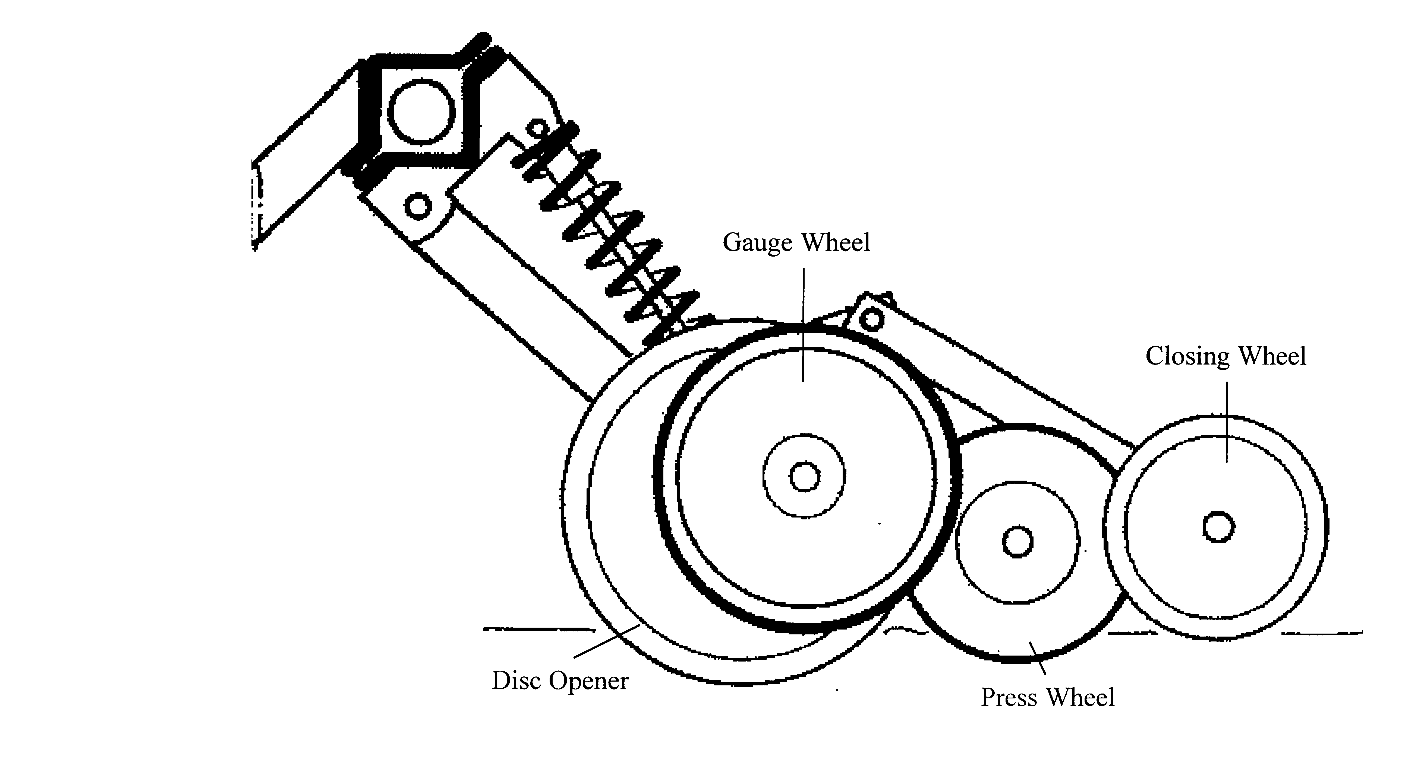
Experiments were conducted in the soil bin facility of the Institute of Agricultural Engineering in the Tropics and Subtropics at Hohenheim University – Germany. The soil bin is 46 m long and 5 m wide and is filled with a sandy loam soil to a depth of 1.2 m. Two types of no-till seed furrow openers were selected for these experiments: (a) single disc opener which is represented by John Deere 750-A no-till opener; Fig. 1, and (b) hoe opener represented by Amazone no-till opener; Fig. 2.
Press Wheel
Gauge Wheel
Closing Wheel
Single Disc Opener
Press Wheel
Gauge Wheel
Closing Wheel
Single Disc Opener
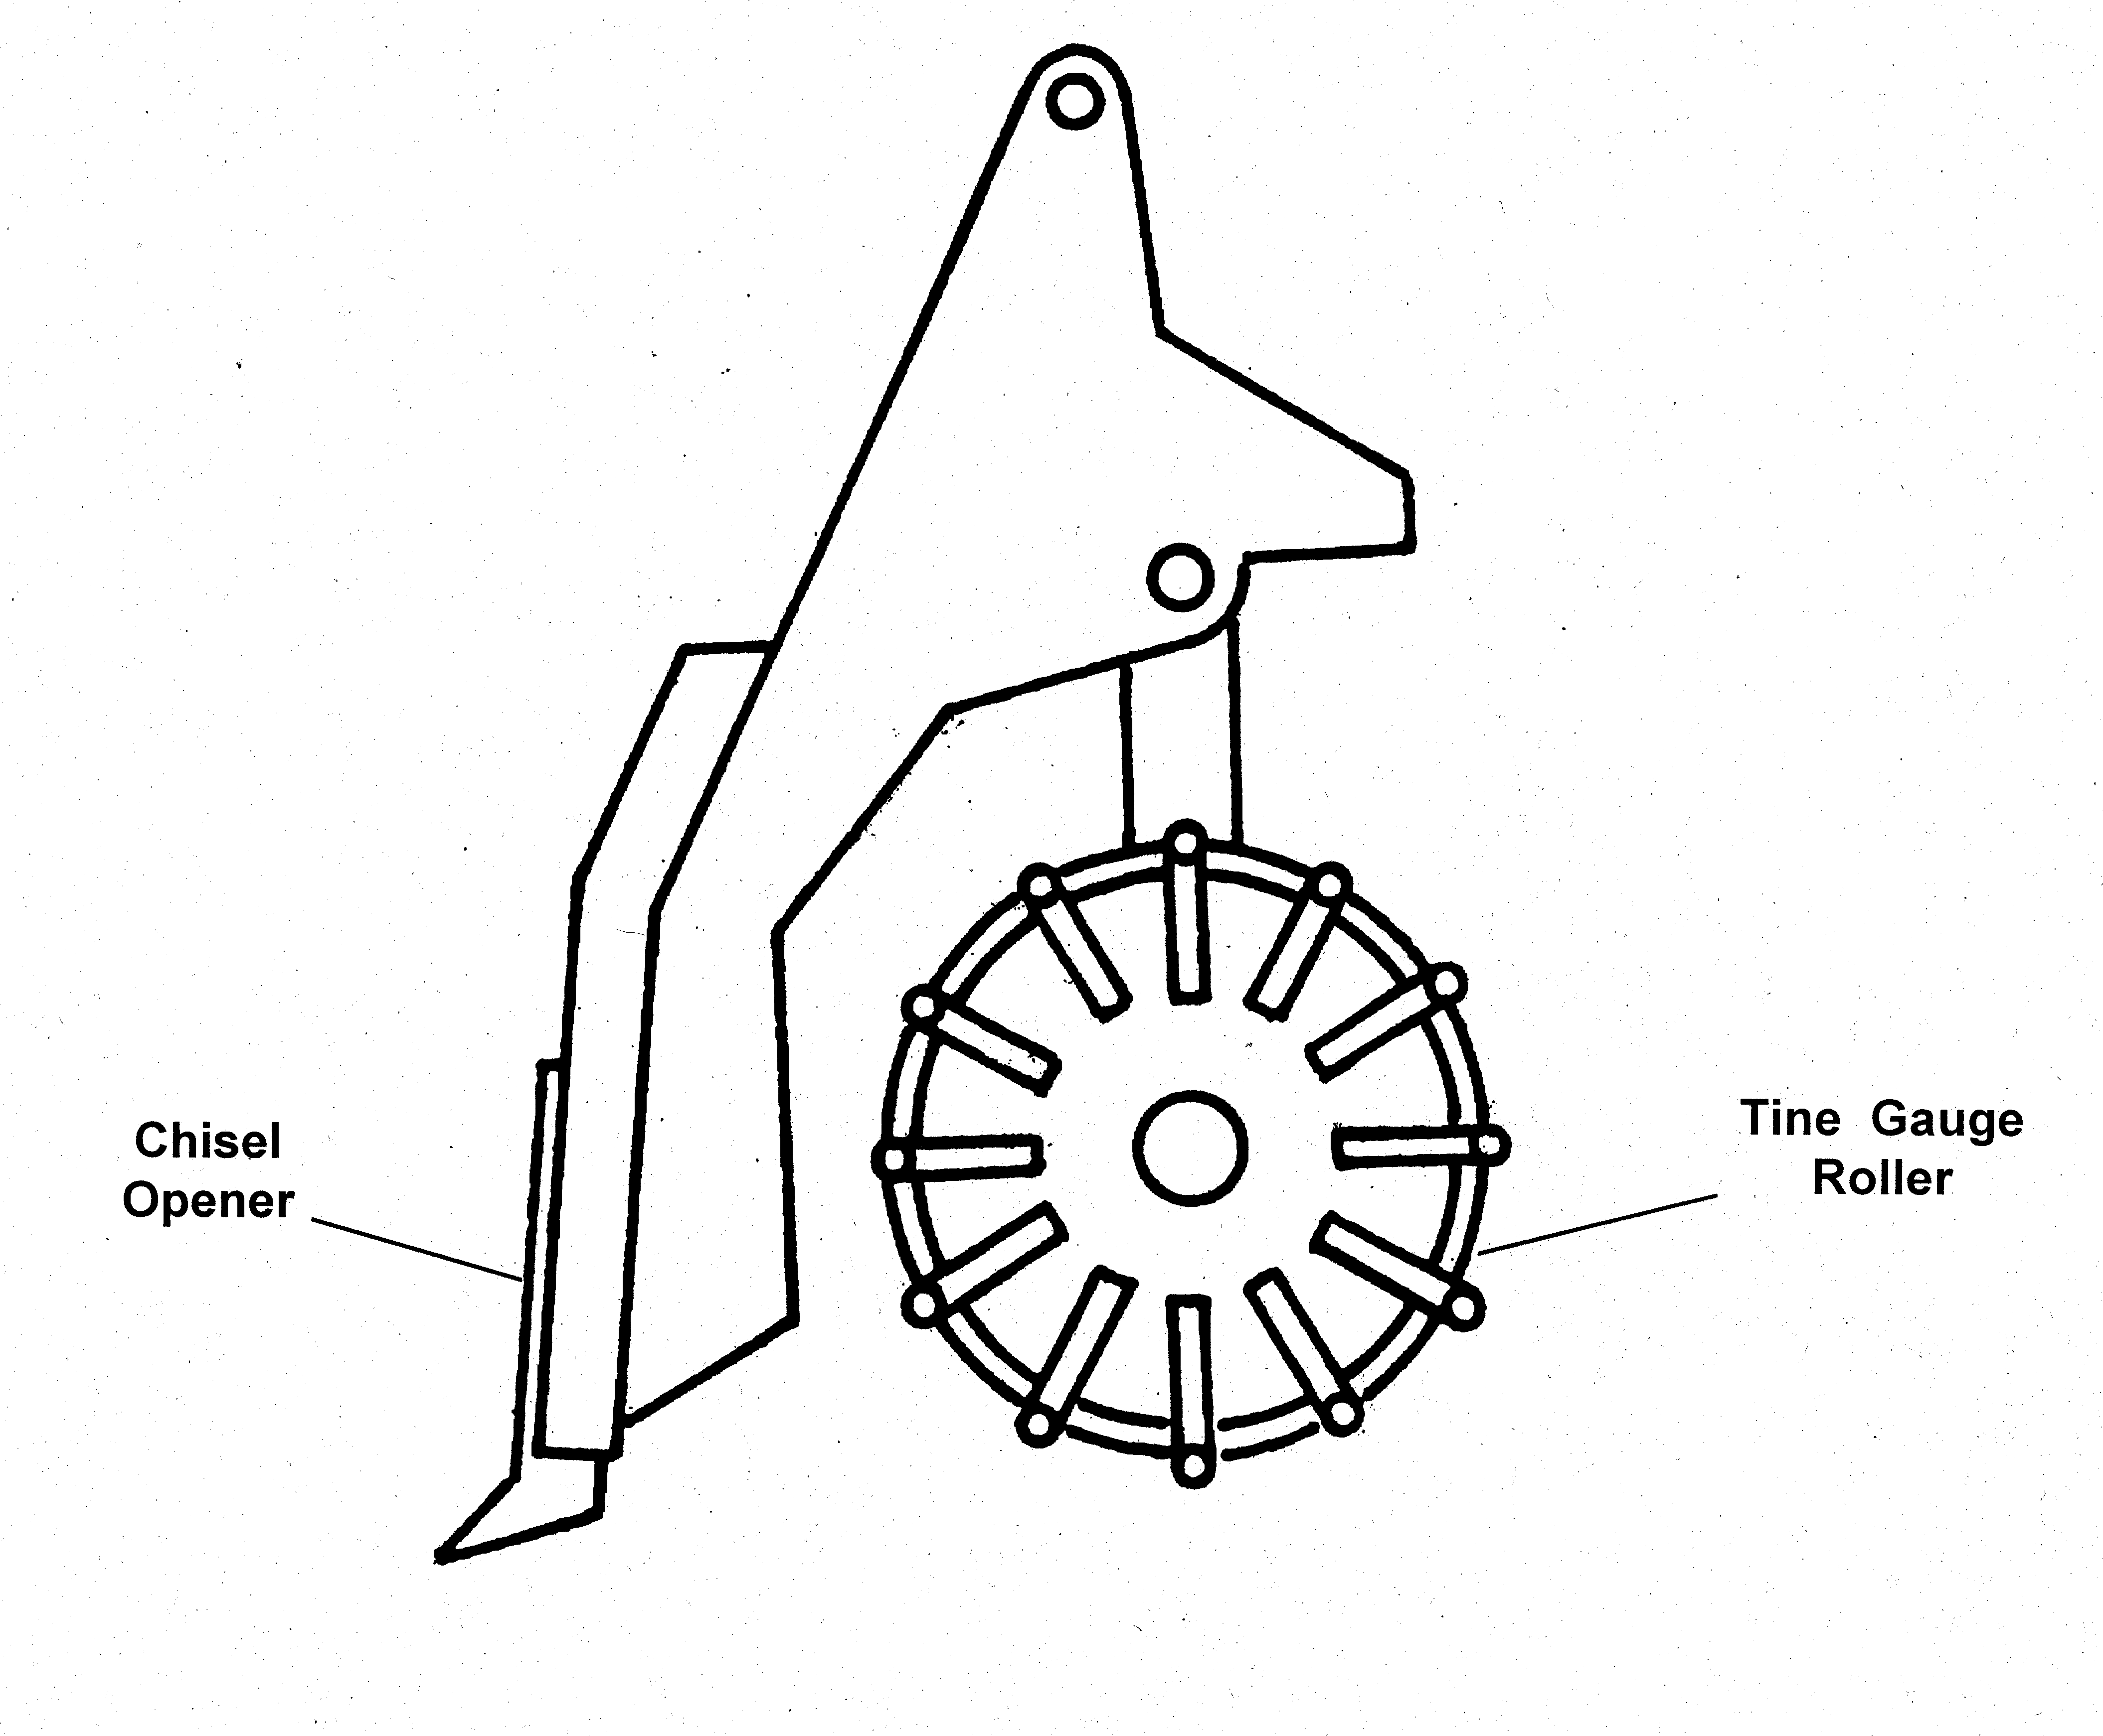
Fig. 2: Amazone No-Till Hoe Furrow Opener

Tine Gauge

Roller
Chisel Opener
Fig. 1: John Deere 750-A No-Till Single Disc Furrow Opener

The performance of these two openers in terms of their effect on the degree of soil loosening in the seed zone is evaluated under two adjusted soil conditions (Table 1) and three crop residue cover rates (0, 3, and 8 t/ha). The two openers were adjusted to operate at a 50 mm soil depth and at a forward speed of 8 km/h.

Table 1: Some Soil Characteristics for the two adjusted soil conditions
Soil Condition | Cone Index, MPa | Dry Density, g/cm³ | Moisture Content, %
1 | 0.60 | 1.42 | 8.1
2 | 0.85 | 1.92 | 13.7

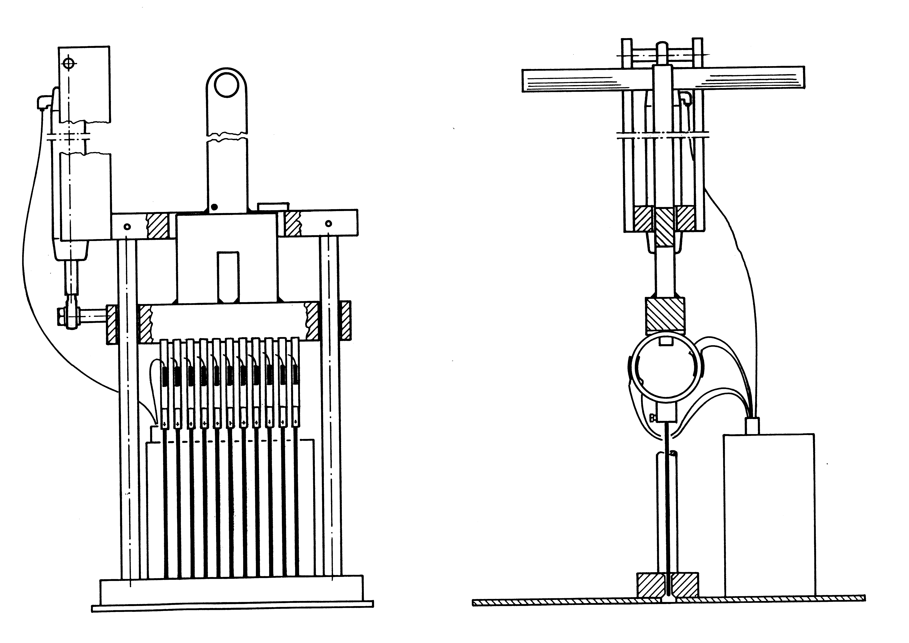
Soil penetration resistance was determined using a multiple cone penetrometer according to Tessier et. al. (1990) and Linke and Köller (1994); Fig. 3. This special penetrometer consists of 11 load cells, each one equipped with a steel probe of 150 mm length with 2 mm diameter. The penetration resistance and the displacement were registered by a portable data logger. Soil penetration resistance is registered every 10 mm to a depth of 140 mm.
Fig. 3: Soil Multiple Cone Penetrometer
Proving Ring
Steel Probe
Handle
Ground Plate
Proving Ring
Ground Plate
Handle
Steel Probe
For better interpretation of the results, the collected observations of soil penetration resistance after treatment were related to the values before treatments so as to estimate the opener-induced soil loosening . The degree of soil loosening in the seed zone is calculated as follows:

$Ψ=\left[1−\frac{{\text{PR}}_{a}}{{\text{PR}}_{b}}\right]⋅\text{100}$ (1)

Where:
 = Degree of soil loosening, %
PR_{a} = Soil penetration resistance after treatments, MPa
PR_{b} = Soil penetration resistance before treatments, MPa

RESULTS and DISCUSSION

The degree to which soil in the seed zone is loosened by the two tested furrow openers is calculated using equation 1. In order to be able to interpret the obtained results, it is important to represent the results as a function of soil depth (by determining the mean values at the same depth along the entire width, Fig. 4) and as a function of the entire width (by determining the mean values at the same position through the desired soil depth).

Fig. 4: Mean values of the degree of soil loosening as a function of soil depth for two no-till furrow openers under soil condition 2 and three crop residue cover rates.

As shown in Figure 4, soil loosening in the seed zone differ markedly between the two tested openers. This figure also shows, that Amazone hoe opener (AM) loosened the soil in the seed zone the most compared to John Deere single disc opener (JD). From Figure 4, it is obvious that the degree of soil loosening is decreasing with the increase in soil depth for the two openers. The induced soil loosening is evaluated also as a function of position relative to the furrow centre for three soil layers (0 – 50, 50 – 100, and 100 – 140 mm soil depth). Example of the results is shown in Fig. 5. Figure 5 shows, that the degree of soil loosening is the most in the top soil layer (0 – 50 mm). Also this figure illustrates, that the highest values of the degree of soil loosening were obtained at the furrow centre and decreased when moving to the sides. The same is stated by Chi and Kushwaha (1990), the initial soil failure started around the bottom of the tool since the highest stress usually occurs in this region. As the load increased, the failure extended around the tool edge first then expanded towards the soil surface.

Fig. 5: Mean values of the degree of soil loosening as a function of position relative to furrow centre for two no-till furrow openers (JD, & AM) under soil condition 1 and 3 t/ha crop residue cover rate.

The total mean values of the degree of soil loosening in each of the three soil layers (0 – 50, 50 – 100, and 100 – 140 mm soil depth) are shown in Figure 6 below:
Fig. 6: Total mean values of the degree of soil loosening in the seed zone as affected by the two tested no-till furrow openers (JD, & AM) for the three soil layers (0-50, 50-100, and 100-140 mm soil depth) under two soil conditions and three crop residue cover rates (0, 3, and 8 t/ha).

The total mean values of the degree of soil loosening in the seed zone for the three soil layers (0-50, 50-100, and 100-140 mm depth) were statistically analysed. The statistical results and Figures 4, 5, and 6 show that:
- Amazone hoe opener (AM) induced high degree of soil loosening with highly significant differences (0.01 level) from that induced by John Deere single disc opener (JD) under both soil conditions and the three crop residue cover rates for the three soil layers.
- The amount of crop residue cover rate has no significant effects on the degree of soil loosening exerted by no-till hoe opener (AM). But it affects the performance of a no-till single disc opener (JD) as follows:
- The degree of soil loosened by (JD) is decreased with the increase in crop residue cover rate, Figures 4, 5, & 6.
- For soil condition 1(with low values of the initial soil strength and soil water content), the effect of residue cover rate on soil loosening by (JD) is significant at 0.05 level only in the top soil layer (0 – 50 mm soil depth).
- For soil condition 2 (with high values of the initial soil strength and soil water content), crop residue cover rates affect soil loosening by (JD) is significant at 0.05 level in the second soil layer (50 – 100 mm soil depth) and at 0.01 level in the third soil layer (100 – 140 mm soil depth).

CONCLUSIONS

From this study we can conclude that:
- No-till furrow opener geometry influences the degree of soil loosening in the seed zone significantly.
- The performance of a no-till hoe opener (AM), in terms of soil loosening in the seed zone, is not significantly affected by the amount of crop residue cover rate.
- The degree of soil loosening by a no-till single disc opener (JD) is significantly affected by the amount of crop residue cover rate.
- Further experiments to correlate no-till openers induced soil loosening, soil strength, soil water content, and crop residue cover rate are needed.

ACKNOWLEDGEMENTS

The authors would like to thank the German Academic Exchange Service (DAAD) for financial allowance, as well as Deere & Company and Amazone Company for technical support.

REFERENCES

Adae, P. C., N. Collis-George, and C. J. Pearson (1991). Over-riding effects of temperature and soil strength on wheat seedlings under minimum and conventional tillage. Field Crops Research, 28(1991): 103 – 116).
Brown, A. D., A. R. Dexter, W. C. T. Chamen, and G. Spoor (1996). Effect of soil macroporosity and aggregate size on seed-soil contact. Soil and Tillage Research vol. 38(3,4): 203 – 216, 1996.
Chi, L. and R. L. Kushwaha(1990). A non-linear 3-D finite element analysis of soil failure with tillage tools. Journal of Terramechanics, vol. 27(4): 343 - 366, 1990.
Domsch, H., E. Lück, and M. Eisenreich (1998). Description of soil structure by means of the penetration resistance and the electrical conductivity. Proceedings of the workshop of the United States Department of Agriculture, Agricultural Research Service, and CIGR on sustainable tillage systems. July 8 – 10, 1998, Auburn University. Editor R. L. Raper. p. 115 – 123.
Hussain, I., K. R. Olson, and S. A. Ebelhar (1999). Impacts of tillage and no-till on production of maize and soybean on an eroded Illinois silt loam soil. Soil and Tillage Research vol. 52 (1-2): 37 – 49.
Kushwaha, R. L., A. S. Vaishnav, and G. C. Zoerb (1986). Soil bin evaluation of disc coulters under no-till crop residue conditions. Transactions of the ASAE, vol. 29(1): 40 – 44, 1986.
Linke, C. and K. Köller (1994). Direct drilling - optimizing of openers current state and first results. Proceedings of the ISTRO 13th International conference on Soil Tillage for Crop Production and Protection of the Environment July 24-29, 1994, Aalborg, Denmark. Editors, Jenson, H.E., P. Schjonning, S.A. Mikkelsen and K. B. Madsen. p. 1207 - 1212.
Prior, S. A., D. C. Reicosky, D. W. Reeves, G. B. Runion, and R. L. Raper (2000). Residue and tillage effects on planting implement-induced short-term CO₂ and water loss from a loamy sand soil in Alabama. Soil and Tillage Research, 54(2000): 197 – 199.
Stephens, L. E., and R. R. Johnson (1993). Soil strength in the seed zone of several planting systems. Soil Sc. Soc. Am. J. 57: 481 – 489 (1993).
Tessier, S., K. E. Saxton, G. M. Hyde, and R. I. Papendick (1990). Seed row compaction and crust meter. Transactions of the ASAE, vol. 33(1): 91 – 94, 1990.
Tessier, S., K. E. Saxton, R. I. Papendick, and G. M. Hyde (1991). Zero-tillage furrow opener effects on seed environment and wheat emergence. Soil and Tillage Research, 21(1991): 361 – 376.

