IMPROVING THE PRODUCTIVITY AND SUSTAINABILITY OF CROPPING SYSTEMS ON FRAGILE SLOPES IN THE HIGHLANDS OF SOUTH CHINA AND THAILAND

M. FULLEN m.fullen@wlv.ac.uk
On behalf of SHASEA (The Sustainable Highland Agriculture in South-East Asia Research Team)
M. FULLEN, T. HOCKING, D. MITCHELL and E. MILNE (The University of Wolverhampton, U.K.)
M. WILSON (The Macaulay Land Use Research Institute, Aberdeen, U.K.)
M. CUDDY, S. STEELE and T. McDONOUGH (The National University of Ireland (Galway), Ireland)
L. BOCK, S. DAUTREBANDE, D. LACROIX, C. CASSE and P. VINCK (Gembloux Agricultural University, Belgium)
WU BO ZHI, LIU LIGUANG, LI YONG MEI, HUANG BIZHI, SUN HAI-QING, CHEN JIDING, WANG SHUHUI and LIU HONG MEI (Yunnan Agricultural University, P.R. China)
WANG YONGZHONG, MA CHENG YUN, PU JIA LIN, JIN ZHEN BIAO and MA SHUN YOU (The Government of Kedu Township, P.R. China)
PANOMTARANCHAGUL MATTIGA, SUKKASEM CHAROON and SANAN PENKRAI (Chiang Mai University, Thailand)

Key words: China, Plastic mulch, Straw mulch, Thailand, Yunnan.

The effectiveness of soil conservation treatments developed in runoff plots is being investigated in farmer-managed plots on a natural catchment. This is being achieved by the development and scientific evaluation of modified and novel cropping practices in a representative highland catchment in Yunnan Province, China. The Wang Jia Catchment covers 57.2 hectares near Kedu, in Xundian County, north-east Yunnan (25o28' N, 102o53' E). The initial project consists of an evaluation of the effects of modified cropping practices on corn productivity and soil properties. This programme has now been extended to investigate ways of increasing the productivity of corn, wheat and soybean on fragile slopes in a sustainable and environmentally-friendly way. The approach incorporates modified and novel agronomic and soil conservation measures, with the evaluation of their agricultural, environmental and socio-economic impacts using multi-disciplinary approaches. This European Union funded project involves an international research team from Belgium, China, Ireland, Thailand and the U.K. The adopted holistic approach includes evaluation of physical, chemical and ecological impacts, the conservation of natural resources, management of wastes, returns for stakeholders, poverty alleviation, income augmentation and rural development. The catchment is being used as an experimental area and training model for sustainable agricultural development in the South China highlands. A parallel study, restricted to scientific evaluation of agronomic and physico-chemical impacts, is being carried out in plot studies at Pangmapa, in the highlands of north Thailand, to test the broader applicability of the cropping practices under development.
Five co-ordinated work packages are being implemented: (1) Background agricultural and environmental assessment of Wang Jia Catchment. (2) Implementation and evaluation of modified and novel cropping systems for wheat, corn and soybean in the catchment. (3) Evaluation of the socio-economic impacts of the changed cropping practices. (4) Comparative scientific evaluation of the cropping techniques in the highlands of northern Thailand. (5) Dissemination of project outcomes and establishment of training programmes for best practice in highland rural development.
The research support infrastructure is now operational at Wang Jia and includes an integrated irrigation system, catchment flume, upgraded access road, Delta-T Weather Station and gully check dams. Considerable progress has been made in the catchment survey (Work Package 1), in which the team is evaluating both the regional external representativeness and internal variability of Wang Jia Catchment. An anticipated outcome is an integrated land information system for humid subtropical highlands. A combination of data sources (field survey, aerial and surface photography, satellite imagery, local maps and GPS survey) is being used to develop georeferenced base maps. These cover geology, land use, vegetation and topography, with associated databases on catchment geomorphology, agropedology and agrohydrology and have been combined into digital elevation models. Catchment soils were sampled and analysed, producing a database of the physical, chemical and mineralogical properties of Wang Jia soils.
A land management plan has been designed and implemented, in consultation with local farmers. This includes afforestation of upper areas with pine, prickly ash and sweet chestnut trees, while arable cultivation is concentrated on the gentler slopes of the mid-part of the catchment. Irrigation facilitates a good wheat crop during the dry winter season and assists early spring growth of corn, thus encouraging the rapid development of crop cover, which protects the soil from erosive monsoon rains. Several field experiments have been established on corn and soybeans (Work Package 2) and crop data support the hypothesis that plastic mulch significantly increases corn productivity. Based on experience gained in field and plots studies, the team designed a composite corn cropping technique called INCOPLAST (Integrated Contour Cultivation, Plastic and Straw Mulch Treatment). In the field, irrigation water is applied prior to monsoon rains. The system is then installed, to both maximise yield (by addition of plastic mulch) and conserve soil, water and associated nutrients (by installation of contour cultivation, straw mulch and use of grass strips around fields). Ridge morphology is shaped to route water towards the corn roots, beneath the plastic mulch. Experiments at Wang Jia proved that soil bulk density beneath the plastic mulch remains low throughout the growing season, thus promoting high infiltration and lower runoff rates. The technique was first installed in Wang Jia in 1999 and is proving extremely beneficial for sustainable crop production. Therefore, analyses are continuing through the 2000-2002 cropping seasons, to evaluate effects during erosive and/or drought seasons. The precise effects on runoff and erosion rates will be established on the runoff plots at Yunnan Agricultural University, starting in 2000.
The team is co-operating with the Thai Department for Land Development in detailed plot studies for Work Package 4 at the Pangmapa field station, in the highlands of northern Thailand (19º33'47" N, 98º12'9" E), where the productivity of corn is being studied in replicated runoff plot experiments. In 1999, plot soils were sampled and analysed and the team designed cropping systems based on the best management practices of both Chinese and Thai agriculture. Chinese systems (ridge tillage, contour cultivation, plastic mulch and INCOPLAST), modified and adapted to Thai conditions, are being applied to 12 Pangmapa plots during 2000-2002. The team believes the interchange of research information between China and Thailand will be beneficial for sustainable development in the highlands of South-East Asia. The project aims to disseminate information to the international research community, regional training agencies, local agricultural and conservation services and village communities.

This Project is funded by The European Union (DGXII) under the ‘International Co-operation with Developing Countries’ Programme (Contract Number ERBIC18 CT98 0326). Conference attendance by M.A. Fullen was partly funded by The Royal Society.

Introduction
Agro-environmental systems in the highlands of South-East Asia are under considerable pressure. Crop yields on sloping land in South China have decreased due to soil erosion and it is possible that in 50-100 years most topsoil will have been removed (Fullen et al., 1998). Rapid industrialisation and urbanisation, coupled to continuing demands for increased food production, are putting further pressure on land use. This is encouraging agricultural intensification and greater use of these fragile areas. More effective soil conservation is therefore essential for sustainable increases in productivity on hill slopes.
The outlined project is an integrated and holistic attempt to increase the productivity and sustainability of cropping systems in the highlands of South-East Asia by the SHASEA (Sustainable Highland Agriculture in South-East Asia) Research Team. It involves the participation of scientists from many different disciplines (agriculture, biology, economics, geology, hydrology and soil science), from different West European and Asian countries, working alongside local farmers and their families in South-East Asia. Attention has particularly focused on the effects of cultivation and conservation treatments on crop productivity and soil erosion rates on the subtropical arable Ultisols of the Upper Yangtze basin in the Central Plateau of Yunnan Province, China.

An Integrated Study of Wang Jia Catchment: Phase 1
To contribute to the development of appropriate soil conservation strategies, a runoff plot study at Yunnan Agricultural University (Lat. 25o08' N, Long. 102o45'E, elevation 1930 m) is evaluating the effectiveness of various soil conservation measures. Various cropping treatments were applied to corn (Zea mays) grown in 30 erosion plots at three different slope angles. A treatment programme has been maintained for each cropping season since 1993. Throughout each season, measurements were taken of runoff and erosion rates, crop yield and yield components and soil thermal and hydrological regimes. Results strongly suggest the benefits of straw mulch and contour cultivation in conserving soil, water and nutrients (Fullen et al., 1997, 1999; Barton 1999).
The team recognised that further progress required full evaluation of the applicability of techniques developed in plot studies to actual field conditions. The research team is achieving this by the development and scientific evaluation of modified and novel cropping practices in a representative highland catchment in north-east Yunnan. The selected catchment, Wang Jia, covers 57.2 hectares near Kedu, in Xundian County (Fig. 1) and serves as a teaching, research and extension facility.
The initial phase of the Wang Jia project consisted of an evaluation of the effects of modified cropping practices on corn productivity and soil properties. Fifteen plots were established in a randomised block design, with five treatments and three replicates, in 1998. The plots were planted with corn and the treatments were: (1) traditional cultivation + downslope planting; (2) traditional cultivation + contour planting, (3) traditional cultivation + contour cultivation + straw mulch, (4) minimum tillage + contour cultivation + straw mulch and (5) traditional cultivation + contour cultivation + polythene mulch. Results in 1998 and 1999 confirm significantly higher corn productivity on areas covered by plastic mulch (Huang Bizhi, Ph.D. thesis in progress).

The Wang Jia Study: Phase 2
Phase 1 of the project provided invaluable preparatory data for Phase 2. It is imperative that the full socio-economic implications of changed cropping strategies are assessed. Preliminary cost-benefit analysis of plot data suggest increased crop yields can increase farm incomes by ~10% per year ($180 per hectare) and thus provide a significant stimulus to the rural economy. There is a strong need to evaluate the effectiveness of any suggested soil conservation strategy within the appropriate socio-economic context. Therefore, the next phase aimed to increase the productivity of wheat, corn and soybean grown on hill slopes in a sustainable and environmentally friendly way. These twin goals of increased productivity and sustainability are being achieved by the development and scientific evaluation of modified and novel cropping practices. Full environmental and socio-economic assessments of these developments are being carried out, covering physical, chemical and ecological impacts, the conservation of natural resources, levels of inputs and losses, management of wastes, returns for stakeholders, poverty alleviation, income augmentation and rural development. This holistic approach has not been attempted previously in this region. The catchment is being used as an experimental area and training model for sustainable agricultural development in the South China highlands.
A project team was assembled to provide multidisciplinary analyses of the complex agro-environmental problems. The SHASEA team consists of scientists from Belgium, China, Ireland, Thailand and the U.K. Results from the plot studies have been used to develop and test novel cropping techniques. This on-going programme has established experiencing-sharing links with the local community (farmers, villagers and township officials), which is proving crucial to incorporating ‘end users’ in the research programme and to ‘bottom-up’ development. The participative research strategy, with the sharing of experience between European and Asian partners, is facilitating the holistic approach, which is essential to the long-term success of this programme.
Five co-ordinated work packages are being implemented: (1) Background agricultural and environmental assessment of the highland catchment. (2) Implementation and evaluation of modified and novel cropping systems for wheat, corn and soybean in the catchment. (3) Evaluation of the socio-economic impact of the changed cropping practices. (4) Comparative scientific evaluation of the cropping techniques in the highlands of northern Thailand. (5) Dissemination of project outcomes and establishment of training programmes for best practice in highland rural development.
The research support infrastructure is now operational at Wang Jia and includes an integrated irrigation system, catchment flume, upgraded access road, Delta-T Weather Station and gully check dams. Considerable progress has been made in the catchment survey (Work Package 1), in which the team is evaluating both the external regional representativeness and internal variability of Wang Jia Catchment. An anticipated outcome is an integrated land information system for humid subtropical highlands. A combination of data sources (field survey, aerial and surface photography, satellite imagery, local maps and GPS survey) are being used to develop georeferenced base maps. These cover geology, land use, vegetation and topography, with associated databases on catchment geomorphology, agropedology and agrohydrology and have been combined into digital elevation models. Catchment soils were sampled and analysed, producing a database of the physical, chemical and mineralogical properties of Wang Jia soils.
A land management plan has been designed and implemented, in consultation with local farmers. This includes afforestation of upper areas with pine, prickly ash and sweet chestnut trees, while arable cultivation is concentrated on the gentler slopes of the mid-part of the catchment. Irrigation facilitates a good wheat crop during the dry winter season and assists early spring growth of corn, thus encouraging the rapid development of crop cover, which protects the soil from erosive monsoon rains. Several field experiments have been established on corn and soybeans (Work Package 2) and crop data support the hypothesis that plastic mulch significantly increases corn productivity.

Development and Initial Evaluation of the INCOPLAST Technique
Based on experience gained in field and plots studies, the team designed a composite corn cropping system to maximise both crop yield and soil and water conservation. The INCOPLAST (Integrated Contour Cultivation, Plastic and Straw Mulch Treatment) combines contour cultivation, straw mulch and plastic mulch. In the field, irrigation water is applied prior to monsoon rains, thereby maximising yield by early establishment of crop growth. The system is then installed, to both maximise yield (by addition of plastic mulch) and conserve soil, water and associated nutrients (by installation of contour cultivation and straw mulch) (Fig. 2). Ridge morphology is shaped to route water towards the corn roots, beneath the plastic mulch. Experiments have proved that soil bulk densities beneath the plastic mulch remain low throughout the growing season, thus promoting easier root penetration, higher infiltration and lower runoff rates.
The INCOPLAST technique was first installed in Wang Jia in 1999 and resulted in significant increases in grain yields (Wang Shuhui, Ph.D. thesis in progress). These positive results have encouraged adoption of the technique by local farmers. Crop yield increases are comparable to the significant improvement produced by plastic mulch. However, INCOPLAST may offer the added advantages of improved soil, moisture and nutrient conservation. It is postulated these benefits will be particularly apparent in erosive and/or drought periods. The INCOPLAST technique will be repeated in the 2000 and 2001 cropping seasons and were applied to the runoff plots in the 2000 cropping season. To enhance soil, water and nutrient retention within fields, experimental plots have been bordered with grasses, including vetiver grass (Vetiveria zizanoides). Evaluation of the performance of the grass is in progress and yielding valuable results. As a tropical grass, vetiver grass is near its climatic tolerance limits and so the results will prove valuable for agro-environmental management in the uplands of South China.

Extending studies to the Highlands of South-East Asia: The Pangmapa Study
A parallel study to the Wang Jia project is scientifically evaluating the agronomic and physico-chemical impacts of improved agronomic techniques and is being carried out in the highlands of north-west Thailand. This sub-project is testing the broader applicability of the cropping practices being developed for South-East Asia. The experimental site is located near Jabo village, Pangmapa District, Maehongson Province (latitude 19o33'47" N, longitude 98o12'9" E, altitude 783 m) and consists of 18 plots each measuring 6 x 40 m (240 m2) on slopes ranging from 30 to 35% (19-23 degrees).

During 1999, the SHASEA team designed cropping systems based on the best management practices of both Chinese and Thai agriculture. Chinese systems (ridge tillage, contour cultivation, plastic mulch and INCOPLAST) have been modified and adapted to Thai conditions. These novel techniques will be applied to 12 of the Pangmapa plots during the 2000-2002 cropping seasons. The team believes this interchange of research information between China and Thailand will be beneficial for sustainable development in the highlands of South-East Asia.

References
Barton, A.P. (1999). Soil erosion and conservation on arable sub-tropical Ultisols in Yunnan Province, China. Ph.D. thesis, The University of Wolverhampton, 291 pp.

Fullen, M.A.; Mitchell, D.J.; Barton, A.P.; Hocking, T.J.; Liu Liguang, Wu Bo Zhi, Zheng Yi and Xia Zheng Yuan (1997). Soil erosion and conservation in Yunnan Province. China Review, Issue 6:27-31.

Fullen, M.A.; Mitchell, D.J.; Barton, A.P.; Hocking, T.J.; Liu Liguang, Wu Bo Zhi, Zheng Yi and Xia Zheng Yuan (1999). Soil erosion and conservation in Yunnan Province, China. Ambio (The Journal of the Royal Swedish Academy of Sciences), 28(2):125-129.

SHASEA Project URL: http://sass2.wlv.ac.uk:8080/school/ab/research/consasia.htm
Figure 1. Plan of the Wang Jia Catchment.
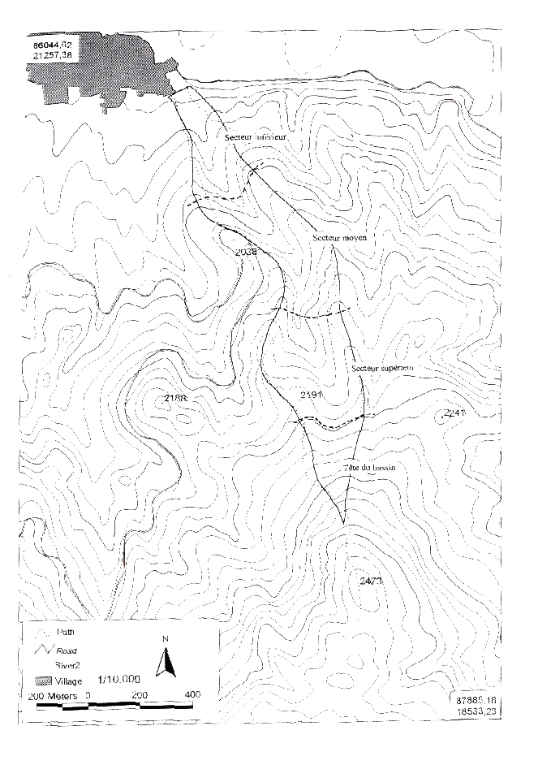

Figure 2. Sketch of the ‘INCOPLAST’ (Integrated Contour Cultivation, Plastic and Straw Mulch Treatment) Technique.

