GIS FOR DECISION-MAKING ABOUT APPLICATION OF
MHD SYSTEMS FOR NATURAL WATER TREATMENT

KUDRJASHOV, V.
Electromagnetic Hydrophysics Laboratory, Agrophysical Research Institute,
14 Grazhdansky avenue, 195220 Saint Petersburg, Russia
e-mail: vk@vk2766.spb.edu ; phone: 7 812 5350057; fax: 7 812 5341900

ABSTRACT
Geoinformation systems (GIS) are an effective means for management of magnetohydrodynamic (MHD) technology application for improvement of natural water properties. The use of GIS for decision support about using of MHD technology in St. Petersburg region was elaborated. A vector map with standard set of geobases was used as a topographic base of the GIS. The thematic set of databases (DB) was created according to long-term observation results of the hydrology service network. On the basis of system approach conception used for analyses of certain criteria of water properties and digital map layers represented vegetation characters, soil types, landscape features and bedrock compositions was marked several zones for MHD technology application efficiency. The more effective zone was connected with the highest values of pH, bicarbonate and carbonate ionic contents, total hardness, and some other parameters of water. This zone is located on elevated areas with sod-carbonate soils overlying by limestone fractured bedrock.

Keywords: geoinformation system (GIS), magnetohydrodynamic (MHD) technology, natural waters

INTRODUCTION
In the modern world decision support systems are widely used for the optimal utilization of various natural resources. In this respect, as an aid for special decision-making systems, GIS are techniques for collecting, storing and processing spatially distributed data [1]. GIS are successfully used for effective applications of some new technologies in the fields of ecology, agriculture and environmental sciences.
MHD treatment of natural waters (NW) and appropriate devices for such treatment are well known around the world as environmentally non-polluting, chemical free and low cost means for improvement of water management technologies for various types of human activity [2,3]. The MHD systems and technology have been successfully applied in numerous branches of technology, agriculture and ecology for many years. In particular, these systems are applied for crop irrigation, leaching of saline or contaminated soils, pre-sowing treatment of plant seeds and in other fields of agricultural and ecological practices [2-4]. Nevertheless, there are certain limitations to applications of these MHD systems which are related to certain specific conditions and ionic compositions in natural waters. Therefore effective testing of MHD systems for NW treatment is needed to applying GIS supported application of MHD technology in areas where the NW has specified ionic compositional and other properties [5].
According to current investigations there are several mechanisms proposed for operating of magnetic treatment systems. These mechanisms are: 1) intra-atomic effects – electron excitation, electron spin interaction, electron transfer, molecular bond breaking, 2) inter-molecular effects – alignment, hydration shell effects, shell rupturing, shell expanding, 3) bulk fluid effects – Hartman effect, MHD effect [6]. Hence it is possible that magnetic systems based on new high-strength magnets, such as permanent ceramic magnets utilizing rare earth metals, may be have advantages for the treatment of NW.

MATERIALS AND METHODS
St Petersburg region
St. Petersburg region has 85900 sq. km area in the northwest part of European Russia (Fig. 1). There are 6,5 million people in the region. Almost all of the region is situated in flat eastern part of the European plain. Gulf of Finland of Baltic Sea lies to the west and the greatest European lakes Ladoga and Onega lie to the east of the region. The region relief is mostly flat with small parts of hilly eminences (Fig. 2). The present relief was originally formed before the Quaternary period but has been greatly changed subsequently.

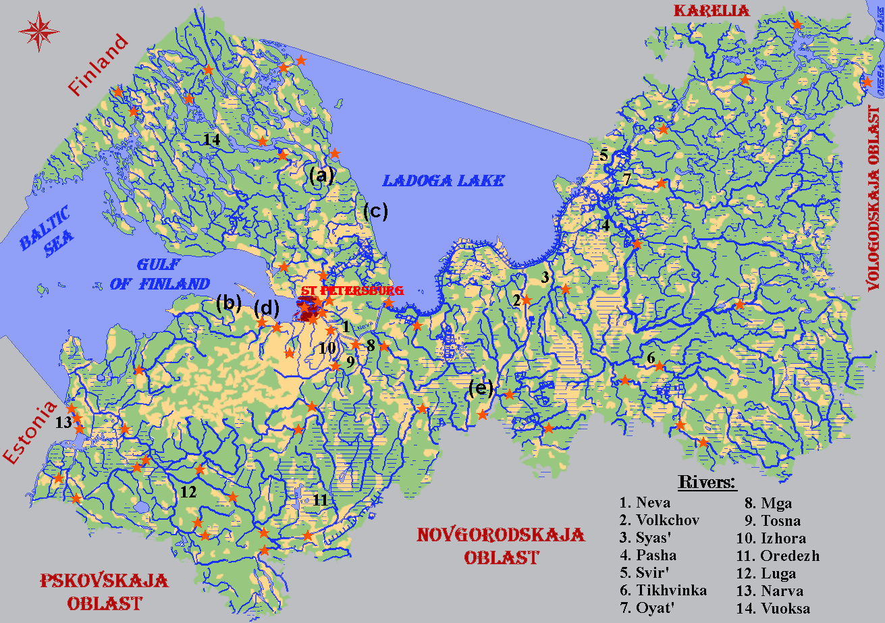

Fig. 1. Digital GIS map of natural water resources for St. Petersburg region.
- sites of hydrological DB locations and connections with geobases;
(a) … (e) - sites of typical landscape photos from Fig. 2.

Region climate has an Atlantic-continental character with the rather mild winter (average temperature of January - 8º — -11º) and temperate cool summer (average temperature of July 16º — 18º). Vegetation of the region is represented by forests with coniferous types of trees in the north and mixed deciduous and coniferous forests in the south. Several types of soils occur, mainly belonging to the acid podzolic, sod-podzolic and peat bog class. The most fertile sod-carbonate soils are widespread in the west-central part of the region. Within the region there are two main landscape types: Baltic shield, which located in north of the region and elsewhere the landscape is typical of the northwest of the Russian plain. The area has the well-developed river networks mainly flowing into the Baltic Sea. The biggest rivers are: Neva, Luga, Volkchov, Svir', Vuoksa and Syas' (Fig. 2). The chemical composition of NW in the region is closely related to the environmental characteristics and is mainly of the soft type with low mineralization.
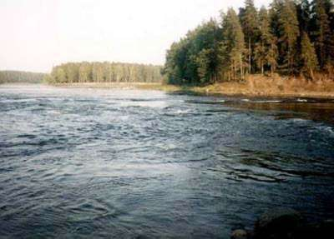 |  | 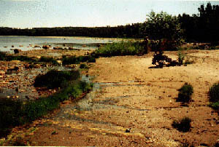
A |  | b
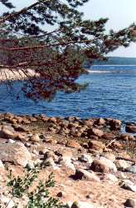 | 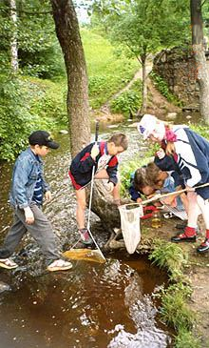 |  | 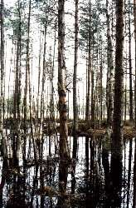
c | d |  | e
Fig. 2. Typical regional landscapes of NW resources network (from the GIS digital collection): a. Vuoksa system of rivers and lakes; b. South coast of Gulf of Finland;
c. Ladoga west lakeside; d. Small river Karasta in south basin of Gulf of Finland;
e. swamp in south-east.

The GIS structure
The GIS employed is designed for decision-making of MHD systems application in St. Petersburg region and performed on IBM/PC under Windows 95/98 operation systems. The basic elements of GIS program graphic windows are shown in Fig. 3. There are stationary and mobile types of the GIS, i.e. for desktop and notebook computers, respectively. Each of these types has a possibility to operate in a peer-to-peer network and also in the Internet by using analog telephone lines. The dynamic exchange of DB was undertaken with the help of Internet techniques using Microsoft approach for DB access. A vector map of the St. Petersburg region with a basic scale 1:1000000 is used as a topographic base of this GIS. Geographic DB in the GIS is corresponded to the exchange format F1M of the Russia Geodesy and Cartography Federal Services and the exchange format DX90 of the International Hydrographic Organization. Thematic (hydrological) DB were created on the base of long-term observation results of the hydrology service network of the Russian HydroMeteoCommittee and also on the base of some fundamental investigations which were fulfilled before this network was founded.
The Optical Character Recognition (OCR) computer technology realized by Fine Reader Pro v.4.64 program was used for transforming common book tables to *.mdb, *.xls or *.dbf formats in depending from future data processing. Designing DB for the GIS were performed with the help of DB management system MS Access 97. In the GIS environment DB was codified and then hierarchically classified according to watershed areas. Hydrology DB were connected to the vector map segments and supplemented by appropriate attributive information such as detailed object description texts, plots and illustration pictures. In each hydrology DB there were from ten to more than twenty parameters of physical properties of water (electroconductivity, pH, clarity, suspended matter etc.), gas composition (CO₂ , O₂ , H₂S, etc.) and contents of main ions (${\text{HCO}}_{3}^{−}$,${\text{CO}}_{3}^{\text{2-}}$,Ca²⁺, Mg²⁺, Na⁺, K⁺ etc.) and also annual dynamics of all these parameters derived from water probe samplings. The GIS may be requested to provide data reports in text, tabular and graphical formats (Fig. 3).

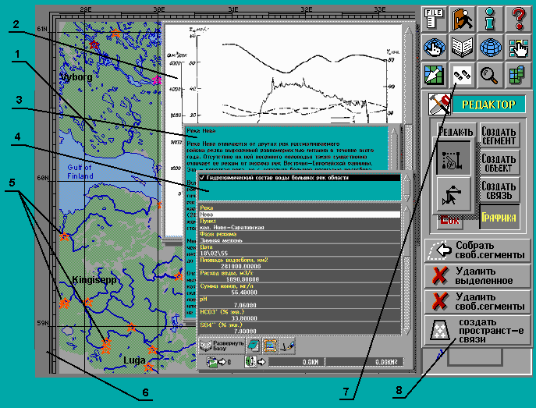

Fig. 3. Basic information GIS window.
1. Digital map; 2. Diagram window; 3. Attributive text window; 4. DB window; 5. Sites of hydrographic DB locations and connections with geobases; 6. Geographic coordinate frame; 7. Program button bar; 8. Vector editor button bar.

Area marking for the MHD system application efficiency was fulfilled on the basis of system approach conception. It was made selective by using filter programs from DB designed according to certain quantitative criteria of ionic contents in NW [8,9]. In addition, analysis of created GIS layers of soils, bedrocks, relief and vegetation was carried out to obtain more information about the conditions of formation of physical, chemical and other properties of NW.

Results and Discussion
Four zones for MHD system efficiency were designated in the area of the St. Petersburg region and are shown in Fig. 4.

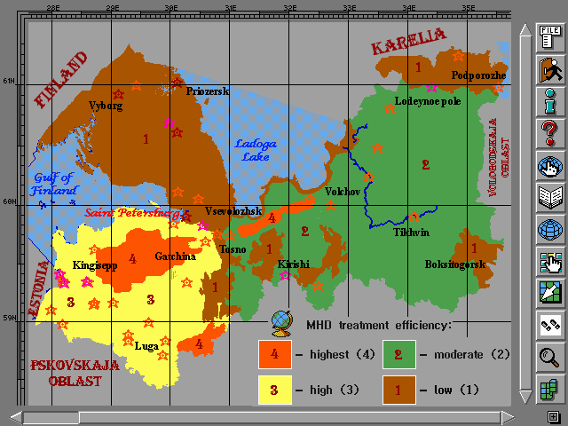

Fig. 4. Thematic map of MHD technology application efficiency in the St. Petersburg region.

The areas with low efficiency of MHD system applications are situated in northwest part of the region, throughout the Karelian isthmus and also in areas of depressed marshland in southeast and east of the region. These areas are characterized by rather soft NW with low hydrocarbonate and carbonate hardness, low total mineralization and low values of pH. Moderate efficiencies of MHD technology applications are in the areas situated in the south and southeast part of the region associated with the Tikhvin ridge and the Ladoga elevation. This zone is characterized by sod-podzolic soils occupied by agricultural lands, deciduous and pine forests. In this zone the values of hydrocarbonate and carbonate hardness, pH, Ca²⁺and Mg²⁺ and total ionic content are greater. The third zone with high efficiency for the application of MHD technology comprises southwest, west and south areas of the region where sod-podzolic soils are used mainly for agriculture but are also occupied by low forest and by pine forests. In these areas the values of pH, hydrocarbonate and carbonate hardness, total mineralization of water and other hydrochemical parameters of NW are more increased. The zone having the greatest possibility of effective application of MHD techniques is characterized by high pH values, bicarbonate and carbonate ionic contents, total hardness, total ionic content in NW etc. This zone is located on elevated areas with spatial distribution of sod-carbonate soils overlying limestone fractured bedrock.
It is necessary to note that the proposed approach for territory estimation for efficiency of MHD technology application on the basis of quantitative criteria of NW chemical properties has some limitations due to annual dynamics of these parameters. Besides it is impossible to formalize qualitative features of environment which have an influence on the occurrence of NW properties.

Conclusions
The GIS technique described for decision-making on the application of MHD technology for NW treatment has remarkable perspectives because the combined application of these modern technologies for increasing the efficiency of water treatment to promote sustainable land management and conservation of soil and water resources.

Acknowledgements
I thank Dr. Brennan Soane from Scottish Institute of Agricultural Engineering for his significant censorious remarks and Prof. N.Ph. Bondarenko from Agrophysical Res. Inst. to give me possibility to realize this project.

REFERENCES
Tsvetkov V.Y. 1998. Geoinformation systems and technologies. Moscow, Finance and statistic, 288 p., (in Russian).
Agricultural Crop Booster. 1999. The Magnetizer Group, Inc., URL: http://www. Magnetizer/crop.htm [26 March 2000].
Bondarenko N.Ph. et al. 1997. Magnetic fields in agriculture and scientific research. St. Petersburg, Agrophysical Res. Inst. Publ., 167 p., (in Russian).
Klassen W.I. 1982. Magnetization of water systems. Moscow, Chemistry Publ., 296 p., (in Russian).
Nilsson G. 1998. Soil remediation of heavy metals and creosote contaminated site. Applied on the former wood-preservation site at Grimstorp, south Sweden. Department of Geology. Earth Sciences Centre, Goteborg University, S-413 81 Goteborg. URL: http://www.aqua-correct.com/goteborg/chalmers.htm [7 April 2000].
Kudrjashov V.A. 2000. Computer geoinformation system for decision-making about using of MHD-devices in Leningrad district. – Proc. of Int. Sci. and Pract. Conf. “Modern Problems of Good Experimental Practice", 5-10 June 2000, St. Petersburg, Agrophysical Res. Inst. Publ., vol.1, pp. 221-224, (in Russian).
Parsons S.A. 1999. What is Magnetic Water Treatment? The School of Water Sciences, Cranfield University. URL: http://www.cranfield.ac.uk/sims/water/magnets.htm [11 June 2000].
Bondarenko N.Ph. et al. 1986. Methodical recommendation about investigations of treatment effects and application of magnetic devices for leaching of saline soils and irrigation of crops. Leningrad, Agrophysical Res. Inst. Publ., 50 p., (in Russian).
Physical Water Conditioning Technic. Nielsen Technical Trading. http://www.aqua-correct.com/dk1skw/uk-oversigt.html [6 April 2000].

